The Dark Side of Punishment
Dan Simon (dsimon@law.usc.edu)
David Kamper (davidgkamper@ucla.edu)

Abstract
The fundamental question that hovers over any criminal system is: why do we punish? The conventional response in the punishment discourse turns to the four canonic purposes: retribution, deterrence, incapacitation, and rehabilitation (aka “justifications of punishment”). These justifications are grounded squarely in moral philosophical theories that are devoted to and driven by laudable pro-social goals, such as human dignity, public safety, and societal welfare. This moral philosophical discourse is both dominant and self-contained so that no other perspective has much to say about why we punish.
Studying a representative sample of 496 US respondents, Study 1 shows that psychological factors exert a strong influence on public punitiveness. We find strong correlations between a host of psychological factors and punitiveness suggesting that punishment behavior is closely related to the punisher’s psychic state. The vast majority of these correlates exhibited forms of hostile aggression that should not be considered normatively appropriate.
Study 2 takes this inquiry one level deeper by focusing on the psychology of retribution, arguably the dominant and most impactful justification. We were particularly interested in testing whether retributivists do in fact abide by the theory’s rather beneficent image. Studying a representative sample of 960 US respondents, we find that those who are classified as retributivists fail to meet these standards and are actually exceptionally hostile and punitive.
The paper ends with a discussion of the implications and normative questions that follow from these findings.

Introduction
The practice of criminal punishment has long been considered “a troubling moral question” (Rawls, 1955, p. 4; see also Allen, 1999). Criminal punishment stirs up a moral quandary because it runs against the general human aversion to inflicting suffering on others (Batson et al., 2005, 2007; Baumeister, 1996; Davis, 1983; Haidt, 2007) and it is fraught also because it entails a brute exercise of force by the liberal democratic state on its citizens (Hobbes, 1651/1994). Nowhere, perhaps, is this quandary as acute as in the unprecedented punitive regime in the United States that has come to be known as mass incarceration (Garland, 2025; National Research Council, 2014).
The fundamental question “why do we punish?” is typically answered by reference to the four canonical purposes of punishment. The core function of these purposes is to prescribe morally justified reasons for meting out criminal punishment, a function that has earned them the label “justifications of punishment.” The state can morally exercise punishment when it satisfies the conditions of retribution, namely, that the offender deserves punishment. It can punish justly also if doing so would deter others from committing crimes, if incapacitating the offender would prevent future crimes, or if punishment would enable their rehabilitation. One cannot overstate the importance of the justifications of punishment. They serve as the gateway to criminal law education, typically inhabiting the first chapter of criminal law casebooks (Ristroph, 2006). The justifications dominate much of criminal law discourse, figuring prominently in legislative debates, legal argumentation, judicial opinions, and the political discourse surrounding criminal policy.
The justifications are grounded squarely in moral philosophy. They concern themselves with high-level concepts such as the categorical imperative, desert theory, and utility maximization, all in the pursuit of laudable values such as human dignity, societal welfare, and personal happiness. Specifically, the justifications are designed to restore justice, reduce crime, and rehabilitate offenders, goals that can be characterized as prosocial. Propped up by the cumulative authority of giants such as Immanuel Kant, Jeremy Bentham, John Stuart Mill, G. W. F. Hegel, John Rawls, and H. L. A. Hart, this justificatory discourse rationalizes and normalizes the state’s use of violence that crushes the lives of its citizens. All punishment, including the regime of mass incarceration, hangs on the legitimacy afforded by this discourse.
Yet, over the years, a small number of jurists and philosophers have sporadically argued that there is more than moral philosophy to understanding what motivates punishment. The English jurist James Fitzjames Stephen (1883) stated that “criminals should be hated, that the punishments inflicted upon them should be so contrived as to give expression to that hatred” (pp. 81-82). As summarized by Murphy (2012), Nietzsche was skeptical of the conscious rationales of justice, rights, and desert that we generally give for retribution, describing it as “ressentiment—an ugly emotional brew of malice, spite, envy, and cruelty” (p. 85). Bentham (1843/1962) too was troubled by the fact that “legislators and men in general are naturally inclined” toward “undue severity” because of “antipathy, or a want of compassion for individuals who are represented as dangerous and vile” (p. 401). Still, the vast majority of jurists and punishment theorists have adhered steadfastly to the conception that punishment is contained and explained entirely within the framework of moral philosophy.
The notion that punishment could be entangled with the psychology of the punisher has attracted a large body of psychological research. Punitiveness, generally defined as the intensity of one’s inclination to impose punishment, has been found to be related to emotions, particularly anger (Gault & Sabini, 2000; Mischkowski et al., 2018), vengeance (DeWall et al., 2007; Jackson et al., 2019), and the urge for retaliation (Ferguson & Rule, 1983). Likewise, punitiveness has been found to be associated with harsh treatment of offenders, tolerance of prison violence (Baron et al., 2026), and the desire to inflict suffering beyond any utilitarian purpose (Fincher & Tetlock, 2015; Gill & Cerce, 2021). Punitiveness has also been found to be linked to the punisher’s ideology and personality, such as authoritarianism (Altemeyer, 1981; Gerber & Jackson, 2013), affinity for hierarchical social ordering (Pratto et al., 1994; Sidanius & Pratto, 2001), and racially resentful dispositions (Chiricos et al., 2004; Unnever & Cullen, 2010). Psychological factors that motivate punitiveness have also been studied in the domains of experimental economics (Fehr & Fischbacher, 2004; Nikiforakis & Mitchell, 2014), brain research (Buckholtz et al., 2008; de Quervain et al., 2004), criminology (Cullen et al., 2000; Pickett, 2019; Wozniak, 2016), developmental psychology (Marshall et al., 2021; Yudkin et al., 2020), evolutionary psychology (Krasnow et al., 2016), and legal psychology (Carlsmith et al., 2002; Carlsmith & Sood, 2009; Darley, 2009). In all, this social science literature makes a compelling case that human punishment is intimately connected with, and driven by, a host of factors and motivations relating to the punisher’s psychology.
This social-scientific literature has been largely overlooked in philosophy and legal scholarship, so much so that the psychology of the punisher is plainly not an issue for the prevailing discourse surrounding the justifications of punishment. Thus, we live in a world where the fundamental question “why do we punish?” has two very different and insulated meanings: a dominant normative account of the permissible reasons for punishing and a marginalized descriptive account of why we actually engage in the practice. This paper challenges the bifurcation by showing that the normative frameworks are indelibly entangled with the psychology of punishment.
Using samples of US adults drawn with quotas for age, sex, ethnicity, and political affiliation, the two studies reported in this paper examine the role that psychological impulses might play in the practice of criminal punishment. Study 1 focuses on the construct of punitiveness. Public punitiveness has been shown to have a crucial impact on punishment policy (Enns, 2014), especially in jurisdictions where policy making is porous to political forces and the pressures of public opinion, as it is in the United States (Green, 2012; Tonry, 2007). The study examines the correlations between a range of factors and punitiveness, focusing especially on factors that would generally be considered to have a non-normative influence on punishment behavior and policy. The study finds that punitiveness is strongly correlated with a host of dark emotions and motivations: hatred towards people convicted of crimes and a desire to degrade them, support for inflicting suffering, acceptance of prison violence, support for revenge, and more. The study also finds strong correlations with personality traits and ideological attitudes that are not easily reconcilable with prosociality, including right-wing authoritarianism, social dominance orientation, violence proneness, and racial resentment. To help gauge the strength of these correlations, the study uses a comparative benchmark in the form of factors that are normatively appropriate and prosocial, namely, perceived crime rates and fear of crime. This comparison reveals that the dark factors are considerably more closely related to punitiveness than the legitimate ones.
Study 2 begins with a replication of the main results of Study 1, and then takes the inquiry deeper by focusing specifically on the framework of retribution. The retributive justification is especially pertinent because it rests strictly on deontological grounds and has been particularly strident in denying any role for psychological factors in our understanding of why we punish. As a preliminary issue, we examine the robustness of the construct of “retribution as just deserts” by testing whether its two components (desert theory and the proportionality principle) hang together. More importantly, we compare, on a host of measures, the participants who ranked retribution first among four reasons for punishment (the retributivists) with the other participants. Our findings show that the retributivists are significantly more punitive and score higher on virtually every other measure we compared. We also examine how well retributivists correspond to the five features that best define contemporary retributivism and which are used to tout retributivism as the most beneficent of justifications. This examination reveals a sharp conflict between the two. As compared with the other participants, retributivists show less commitment to the dignity of the punished person, were more willing to depart from the principle of proportionality, are more punitive, show less fidelity to the due process owed to criminal defendants, and are more beset by dark motivations, emotions, beliefs, and personality traits. In short, these findings suggest a discontinuity between retribution theory and how it is experienced by people who subscribe to it.

Study 1
One goal of Study 1 is methodological in nature. The abovementioned literature on the psychology of punishment has three notable limitations. For one, the bulk of this literature is dispersed across a wide swath of studies, each covering just limited slivers of the field (for exceptions, see Gerber & Jackson, 2013; Jackson et al., 2019; King & Maruna, 2009; Okimoto et al., 2012; Raihani & Bshary, 2019). The field lacks a macro-level view capable of gauging the relative strength of the various correlates and examining their interrelationships. Second, the field is hindered by the absence of a standard operationalization of punitiveness itself (see Adriaenssen & Aertsen, 2015; Gerber, 2021). Some studies operationalized punitiveness basing it on penological attitudes (e.g., Cullen et al., 1985), soliciting sentencing recommendations (e.g., Carlsmith, 2008), and tapping support for specific sentencing policies (e.g., Tyler & Boeckmann, 1997). This lack of uniformity makes it difficult to theorize about the findings borne by different studies. Third, the extant literature does not offer a useful way to gauge the overall magnitude and implications of the dark forces’ impact on punishment. For these reasons, perhaps, the extant findings have failed to coalesce into a programmatic framework capable of offering a broad and sustained critical take on this vital public policy.
The present studies seek to address these limitations. First, the studies conduct a wide-ranging correlational investigation of the punitiveness ecosystem, measuring how twenty-four psychological constructs relate to punitiveness and to one another. These constructs are organized into four thematic clusters: concerns over crime, emotional reactions, hostile aggression, and personality/ideological factors. This design enables us to examine the field at two different magnifications: a detailed construct-level view and a macro-level cluster view. To address the longstanding operationalization problem, we measure punitiveness using an unusually diverse composite that combines six scores containing penological attitudes, policy preferences, and a sentencing decision. Finally, to address the need to gauge the magnitude of the dark psychological factors, we examine the association between punitiveness and two normatively appropriate factors. Those factors can serve as a benchmark to help us assess, at least in general terms, just how impactful the dark psychological forces are. For a benchmark, we focus on participants’ concerns about crime, consisting of perceptions of crime rates (Applegate et al., 2002; Hough & Roberts, 2005; Pickett, 2019), and fear of crime (Hough & Roberts, 2005; Gerber, 2021; Pickett, 2019). Indeed, it is widely believed that concerns about crime are the logical and normatively appropriate impetus for criminal punishment (Enns, 2016; Pickett, 2019; Roberts et al., 2003).

Study 1 Method
Study 1 was preregistered on the Open Science Framework (osf.io/kr7y2). For both studies, we report how we determined our sample size, all data exclusions, all manipulations, and all measures (Simmons et al., 2012).

Participants
Adults living in the United States were recruited through Prolific’s representative sample, with quotas for age, sex, ethnicity, and political affiliation. They completed the survey in Qualtrics between December 2, 2025, and January 7, 2026. Participants read an information sheet, consented by completing the survey, and were compensated at Prolific’s standard rate. The study was approved by the Institutional Review Board at the University of Southern California.
The preregistered target was 480. Of 514 responses, 15 were incomplete. Of the 499 complete responses, 2 failed the first attention check, which asked participants to select “strongly agree,” and 1 failed the second (“What is 8+7 equal to?”), leaving 496. These exclusion rules were not preregistered.
Participants averaged 46.2 years of age (SD = 16.2, range 19–85); 50.2% were women, 49.2% were men, and 0.6% chose “other.” Asked to choose one of seven categories, 65.3% identified as White and non-Hispanic, 13.3% as Black or African American, 10.7% as Hispanic or Latino, 7.9% as Asian, and 2.8% as Native American, Middle Eastern, or Pacific Islander. On a 7-point liberal–conservative scale, 38.3% placed themselves on the liberal side (1–3), 23.4% at the midpoint, and 38.3% on the conservative side (5–7); the analyses call these groups liberals, moderates, and conservatives.

Procedure and Measures
Study 1 is a correlational survey. After the information sheet and brief instructions, participants completed eight blocks in a fixed order, described here in that order, and could not return to an earlier screen. Within each block of rating items, the items appeared in a new random order for each participant, except that the first attention check always closed the punitiveness block and the rows of the single grid question (regarding television viewership) kept a fixed order. Unless noted, items were rated on a 7-point scale labeled strongly disagree (1), neutral (4), and strongly agree (7); the response scales for crime concerns and emotions were labeled only at the ends (e.g., not at all and very much so). Every rating item, the sentence, and each demographic question required an answer, so none has a missing value. Each measure is the mean of its items after reverse coding, so that a high score means more of the named attitude. In both studies, items are quoted as participants saw them.
Punitiveness (Block 1). Eight items measured five components of punitiveness: support for more punishment (two items, one reversed; e.g., “The solution to crime is more punishment”), rejection of parsimony (two items, both reversed; e.g., “The state should not punish more than is absolutely necessary”), support for three-strikes laws (two items), support for life without parole (one item), and support for the death penalty (one item, rated from strongly oppose to strongly support on 7 points rather than the preregistration’s 5). The sixth component is the recommended sentence, which was presented towards the end of the study to prevent the crime vignette from impacting other measures. To increase the generalizability of the sentencing decision, each participant was presented with one of three vignettes, all involving a conviction for second-degree murder. The sentence decision was standardized within vignette as preregistered. Punitiveness is the mean of the six components, each standardized, so that each carries the same weight. The preregistration names the six components without saying how they are combined. Where an analysis relates punitiveness to the sentence itself, punitiveness leaves the sentence out: it is the mean of the five attitude components, each standardized.
Crime concerns (Block 2). Participants next rated perceived crime rates (two items; e.g., “How serious is the problem of crime in the United States?”, rated from not serious at all to very serious) and fear of crime (three items, one reversed).
Due process (Block 3). The third block measured due-process permissiveness (three items, one reversed; e.g., “People charged with committing violent crimes should be convicted even if police investigators cut some corners”) and willingness to convict on uncertain evidence (four items; e.g., “If police officers know that a defendant is guilty, it is okay for them to lie when testifying in court to help obtain a conviction”). The second attention check appeared among these items.
Emotions (Block 4). The fourth block measured hatred of offenders (three items, one reversed; e.g., “I feel hatred towards criminals”) and anger (two items). We used the term “criminals” advisedly with the goal of mimicking language that is common in the public discourse.
Harshness (Block 5). The fifth block measured social exclusion (three items; e.g., “By breaking society’s laws, criminals exclude themselves from membership in society”), degradation (three items, one reversed; e.g., “Punishment should humiliate the criminal”), infliction of suffering (two items; e.g., “Punishment without suffering is not punishment”), tolerance of prison violence (two items, both reversed; e.g., “I feel bad when a prisoner is assaulted in prison”), support for harsh prison conditions (three items, one reversed), and revenge (three items: “Society has the right to take revenge on criminal offenders,” “Society should punish to get back at criminal offenders,” and “A father should not be prosecuted for killing the man who raped his 9-year old daughter”).
Personality and ideology (Block 6). Six scales followed in random order: right-wing authoritarianism (five items, one reversed, adapted from the Very Short Authoritarianism scale of Bizumic & Duckitt, 2018), social dominance orientation (the eight-item short form of the SDO₇ scale; Ho et al., 2015; four items reversed, rated for agreement rather than favor), trait vengefulness (five items, two reversed), violence proneness (four items; e.g., “Physical punishment is necessary for raising children”), racial resentment (four items, two reversed, adapted from Kinder & Sanders, 1996), and a grid asking how much participants liked watching nine types of television shows, rated from dislike very much to like very much. Blood sports viewership is the mean of four rows of the grid: boxing, mixed martial arts, hunting, and professional wrestling. The other measures were drawn or adapted from Cullen et al. (1985), Gallup (2025), Gerber and Jackson (2013), Hogan et al. (2005), King and Maruna (2009), Lecci and Myers (2008), Tetlock et al. (2007), Tyler and Boeckmann (1997), and Wozniak (2016), or written for this study.
Sentencing (Block 7). Qualtrics assigned each participant at random to one of three vignettes, without balancing the groups. In each, Darryl Smith kills Frankie Williams: a teacher whose purse he tries to snatch (Vignette A), a woman he has dated who has a restraining order against him (Vignette B), or a drug dealer whom Darryl suspects of informing the police about his car-theft operation (Vignette C). Participants were asked what punishment Darryl “deserves for this crime” and told to “[a]ssume that Darryl’s conduct amounts to second degree murder.” They could give 0 to 50 years, 50 being “generally equivalent to life in prison,” and were told that “[m]ost sentences given by judges for similar charges range from 20 to 30 years.” They set the sentence on a slider in whole years. Two optional prompts followed: “Please explain why you recommended this sentence for Darryl” and “What do you hope this sentence will accomplish?” The preregistration specifies a single prompt, worded differently. The free form answers are not analyzed here.
Demographics (Block 8). Participants gave their age, gender, race and ethnicity, and education, and placed themselves on the liberal–conservative scale.

Analytic Strategy
The preregistration predicts that punitiveness will be “positively correlated with all listed correlate measures” (H1), that the hostile aggression cluster will correlate with it more strongly than the crime concerns cluster (H2), and that most correlates will be positively intercorrelated (H3). It groups the 18 correlates into five clusters, each scored here as the mean of its items: crime concerns (perceived crime rates and fear of crime), emotions (hatred and anger), hostile aggression (social exclusion, degradation, infliction of suffering, tolerance of prison violence, harsh prison conditions, and revenge), personality and ideology (the six measures of Block 6, of which the preregistration labels blood sports viewership exploratory), and process violations (due-process permissiveness and convicting on uncertain evidence). The analyses treat the first four clusters as confirmatory and process violations as exploratory, although the cluster’s two measures remain among the correlates of H1 and H3. The preregistration’s statement of H2 names hatred, revenge, degradation, infliction of suffering, and tolerance of prison violence as hostile aggression; the analyses follow its list of measures, which places hatred among the emotions and adds social exclusion and harsh prison conditions.
All Study 1 tests are two-sided at α = .05, and associations are Pearson correlations with 95% confidence intervals from Fisher’s z transformation. H2 was tested, as preregistered, with Steiger’s (1980) test. The preregistration calls for false discovery rate correction of construct-level analyses. We read that rule narrowly: we applied the Benjamini–Hochberg procedure (Benjamini & Hochberg, 1995) to the 18 H1 correlations and report the 153 correlations among the correlates, which bear on H3, by their sign and without correction. Stability across vignettes was assessed, as preregistered, from the correlations within each vignette and from a mixed-effects model with a random intercept for vignette. The preregistration also names, as exploratory, moderation by political orientation, race, gender, and age, and a confirmatory factor analysis of a “theoretical 8-cluster model.” Moderation was tested by regressing punitiveness on one of four standardized correlates (hostile aggression, crime concerns, right-wing authoritarianism, and racial resentment), a moderator, and their product, with race coded as White versus non-White and in seven categories (the latter tested by an omnibus F). The choice of these four correlates, education as a further moderator, the same models with the sentence as the outcome (controlling for punitiveness without the sentence), and Benjamini–Hochberg correction within each set of 24 moderation tests were not preregistered (Section S1). The preregistration groups the correlates into five clusters, not eight, so the factor model, fitted by maximum likelihood, has four correlated factors, one for each confirmatory cluster, with the 16 measures as indicators. The preregistration further lists an exploratory factor analysis and its comparison with the confirmatory model, the shares of participants above and below each scale’s midpoint, and thematic coding of the open-ended answers; these are not reported here. Analyses added after the preregistration are listed in Section S1 of the Supplementary Materials.
Analyses were run in R 4.5.2 (R Core Team, 2025) with psych 2.6.5 (Revelle, 2026) for reliability, cocor 1.1-4 (Diedenhofen & Musch, 2015) for Steiger’s test, boot 1.3-32 (Canty & Ripley, 2025) for bootstrap intervals, car 3.1-5 (Fox & Weisberg, 2019) for the omnibus F tests, lavaan 0.6-21 (Rosseel, 2012) for the factor model, and lme4 2.0-1 (Bates et al., 2015) for the mixed-effects model.

Study 1 Results

Sample, Measures, and the Sentencing Decision
Table 1 gives the number of items, reliability, mean, and standard deviation of each measure. Across the individual multi-item measures, α ranged from .48 (rejection of parsimony) to .92 (social dominance orientation); several fell below .70, which attenuates correlations involving them.

Table 1
The Measures of Study 1: Items, Reliability, Descriptive Statistics, and Correlations With Punitiveness
Measure | k | α | M | SD | r with punitiveness [95% CI]
Punitiveness
Punitiveness (six components) | 6 | .802 | 0.00 | 0.71
Support for more punishment | 2 | .683 | 4.12 | 1.63
Rejection of parsimony | 2 | .477 | 4.21 | 1.31
Support for three-strikes laws | 2 | .751 | 3.20 | 1.69
Support for life without parole | 1 |  | 4.99 | 1.78
Support for the death penalty | 1 |  | 4.31 | 2.07
Sentence (years) | 1 |  | 35.19 | 12.51
Crime concerns
Perceived crime rates | 2 | .845 | 5.00 | 1.42 | .443 [.369, .511]
Fear of crime | 3 | .780 | 3.02 | 1.34 | .202 [.116, .285]
Emotions
Hatred | 3 | .778 | 4.34 | 1.44 | .620 [.563, .671]
Anger | 2 | .828 | 4.84 | 1.51 | .518 [.450, .580]
Hostile aggression
Social exclusion | 3 | .761 | 4.46 | 1.45 | .610 [.552, .663]
Degradation | 3 | .670 | 3.66 | 1.37 | .530 [.463, .590]
Infliction of suffering | 2 | .794 | 3.82 | 1.68 | .601 [.542, .655]
Tolerance of prison violence | 2 | .559 | 3.04 | 1.38 | .438 [.364, .507]
Harsh prison conditions | 3 | .818 | 3.30 | 1.55 | .667 [.615, .713]
Revenge | 3 | .665 | 4.11 | 1.43 | .504 [.435, .567]
Personality and ideology
Right-wing authoritarianism | 5 | .869 | 3.72 | 1.65 | .602 [.543, .655]
Social dominance orientation | 8 | .923 | 2.58 | 1.44 | .416 [.340, .486]
Trait vengefulness | 5 | .879 | 2.97 | 1.41 | .190 [.104, .274]
Violence proneness | 4 | .729 | 3.29 | 1.41 | .507 [.438, .570]
Racial resentment | 4 | .904 | 3.52 | 1.76 | .544 [.479, .603]
Blood sports viewership | 4 | .837 | 3.17 | 1.60 | .166 [.079, .251]
Process violations
Due-process permissiveness | 3 | .598 | 3.02 | 1.18 | .534 [.468, .594]
Convicting on uncertain evidence | 4 | .667 | 3.17 | 1.12 | .461 [.388, .527]
Clusters
Crime concerns | 5 | .782 | 3.81 | 1.15 | .360 [.280, .434]
Emotions | 5 | .865 | 4.54 | 1.36 | .622 [.565, .673]
Hostile aggression | 16 | .921 | 3.77 | 1.21 | .690 [.641, .734]
Personality and ideology | 30 | .924 | 3.13 | 1.05 | .597 [.538, .651]
Process violations | 7 | .758 | 3.11 | 1.01 | .558 [.495, .616]
Note. N = 496. k is the number of items. Attitude items were rated from 1 to 7 and the sentence from 0 to 50 years (50 = life). Punitiveness is the mean of the six components listed under it, each standardized; the sentence is first standardized within vignette. Punitiveness therefore has a mean of 0; its k is the number of components, and its α is computed across the six standardized components. Each cluster is the mean of the items of its measures; process violations, the cluster of the two process measures, is exploratory. The 18 correlations of the individual measures were tested two-sided with Benjamini–Hochberg correction, and all 18 remained significant (largest corrected p < .001).
On average, participants gave sentences longer than the 20-to-30-year range that the instructions described as typical for similar charges. The mean sentence was 35.2 years (SD = 12.5, Mdn = 35), 10.2 years above the 25-year midpoint of that range, t(495) = 18.14, p < .001, d = 0.81, in a test that was not registered. The distribution was left-skewed (skew = −0.24) and constrained by its ceiling: 32.3% of participants gave the 50-year maximum (Figure 1). The 496 participants were divided among the three vignettes as 168, 176, and 152, and the mean sentence exceeded 25 years in each vignette (Supplementary Materials, Section S1); the median participant finished the study in 15.7 minutes (interquartile range 11.6–21.9).

Figure 1
Sentences in Study 1
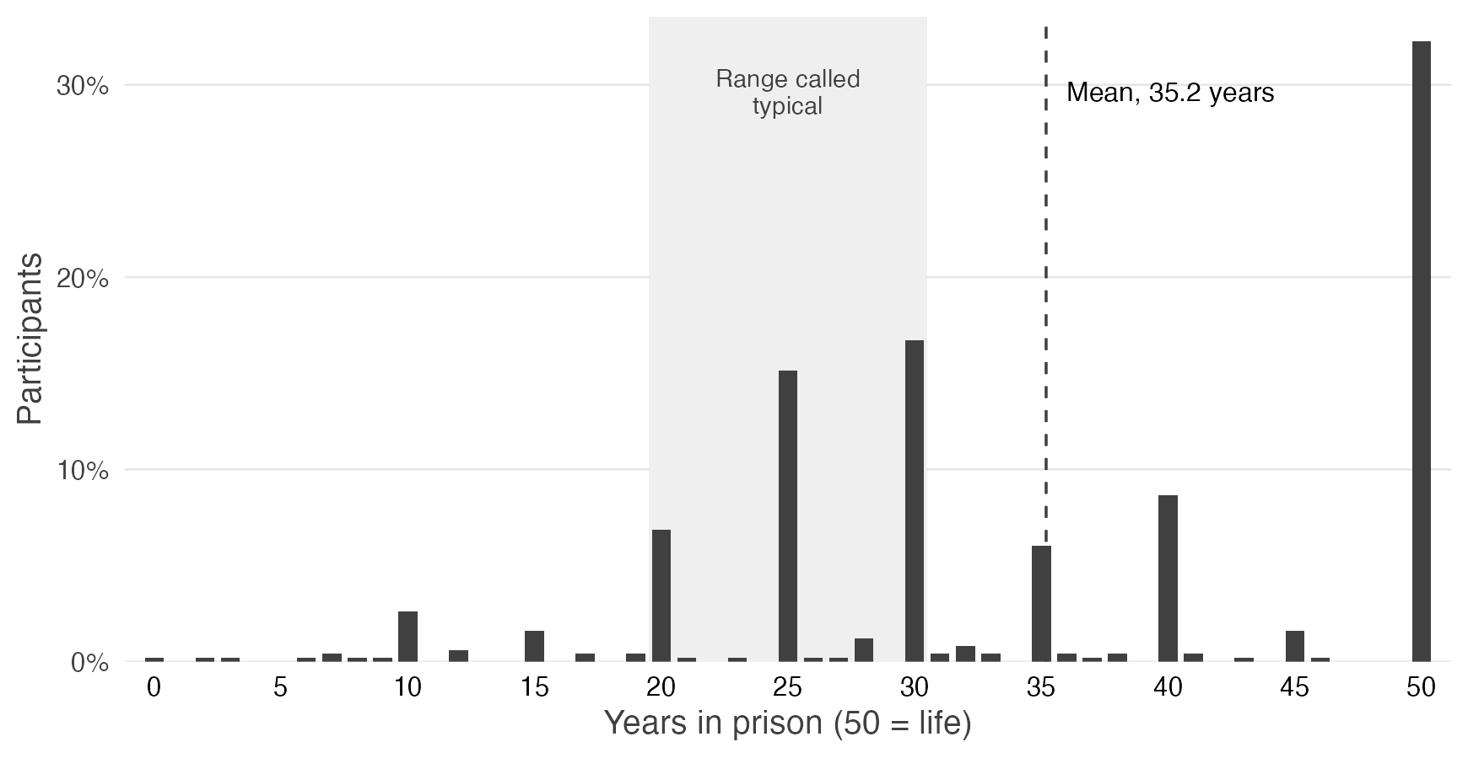
Note. Bars show the percentage of participants who chose each sentence, in whole years from 0 to 50 (50 = life). The shaded band marks the 20-to-30-year range that the instructions described as typical for similar charges, and the dashed line marks the mean, 35.2 years; 32.3% of participants chose the 50-year maximum. N = 496.

Hypothesis 1: Punitiveness Is Related to All Eighteen Correlates
Hypothesis 1 was supported. All 18 correlates were positively related to punitiveness, and all 18 correlations were significant after Benjamini–Hochberg correction (Table 1). The strongest were with harsh prison conditions (r = .667), hatred of offenders (r = .620), social exclusion (r = .610), right-wing authoritarianism (r = .602), and infliction of suffering (r = .601). The two measures of crime concerns correlated more weakly than these (perceived crime rates, r = .443; fear of crime, r = .202). The weakest correlations were with trait vengefulness (r = .190) and blood sports viewership (r = .166); differences between individual correlations were not tested.
Of the four confirmatory clusters of correlates, crime concerns correlated least with punitiveness (Figure 2): hostile aggression, r = .690, 95% CI [.641, .734]; emotions, r = .622, [.565, .673]; personality and ideology, r = .597, [.538, .651]; and crime concerns, r = .360, [.280, .434]. Steiger’s tests showed that each of the other three clusters correlated more strongly with punitiveness than crime concerns did (all three p < .001; the tests of emotions and of personality and ideology were not registered).

Figure 2
Correlations Among Punitiveness and the Correlate Clusters in Study 1
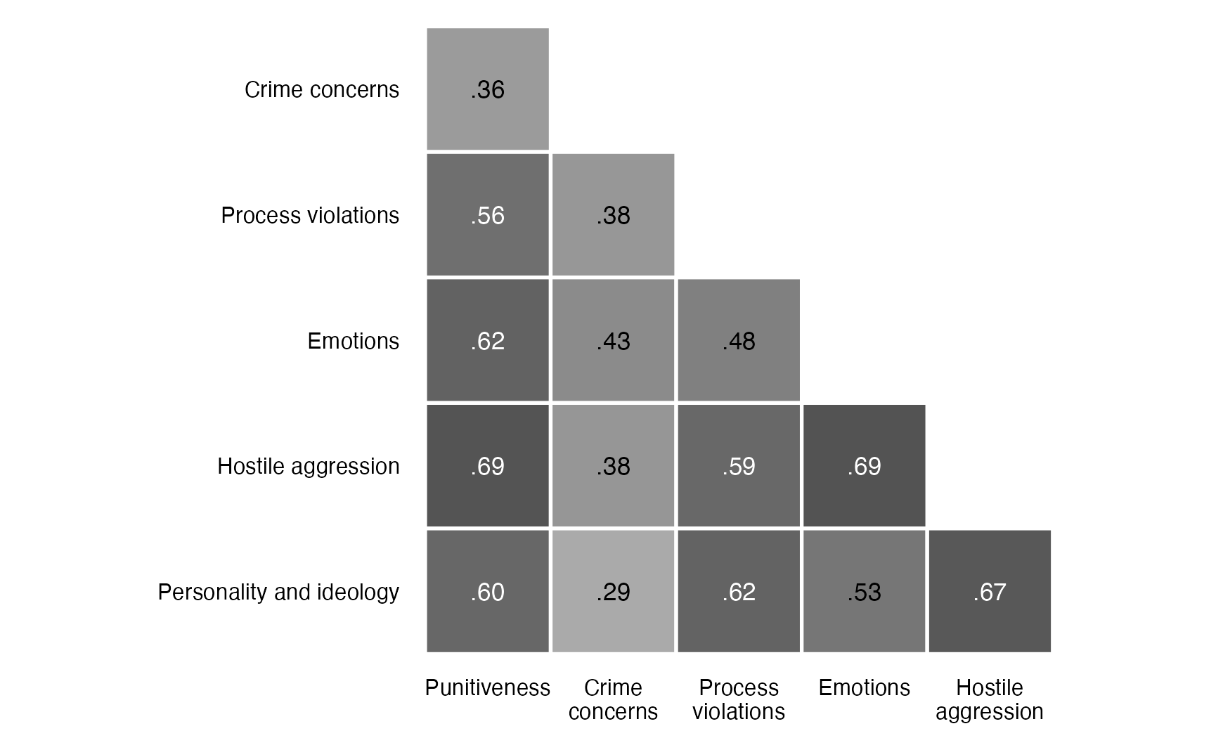
Note. Each cell gives the Pearson correlation of two scores; darker shading indicates a stronger positive correlation. The figure includes punitiveness, the four confirmatory clusters (crime concerns, emotions, hostile aggression, and personality and ideology), and the exploratory process violations cluster. Hostile aggression correlates most strongly with punitiveness (r = .690), and crime concerns least strongly (r = .360); Hypothesis 2 tests their difference. N = 496.

Hypothesis 2: Hostile Aggression Correlates More Strongly Than Crime Concerns
Hypothesis 2 was supported: punitiveness was more closely related to hostility toward offenders than to concern about crime. In the study’s central confirmatory test, the hostile aggression cluster correlated with punitiveness at r = .690 and the crime concerns cluster at r = .360, Steiger’s Z = 8.54, p < .001. We call this gap the hostile aggression advantage. Its bias-corrected and accelerated (BCa) bootstrap 95% confidence interval, which was not registered, excluded zero, ∆r = .331, BCa CI [.240, .431]. Because both correlations come from the same participants at the same time, the comparison shows which attitude is more closely related to punitiveness, not that either attitude produces it.
The advantage does not depend on the hostile aggression measures whose content is closest to the punitiveness items. In analyses that were not registered, it held when the cluster was narrowed to the four measures least likely to restate punitiveness, and again when only social exclusion and revenge remained, ∆r = .263, Z = 6.38, p < .001, BCa CI [.166, .366] (Table S1). When each of the six components of punitiveness was analyzed separately, with all six hostile aggression measures and without correction for multiple tests, the advantage appeared on five (Supplementary Materials, Section S1). The exception was the sentencing decision (∆r = .078, Z = 1.60, p = .11, two-sided), to which Study 2 returns with a larger sample.

Hypothesis 3: The Correlates Are Positively Intercorrelated
Hypothesis 3 was supported: the correlates were positively intercorrelated, a pattern consistent with a cohesive mindset rather than a loose collection of unrelated attitudes. All 153 correlations among the 18 correlates were positive, ranging from r = .021 to .717. Because the hypothesis concerns their sign, they are reported descriptively, without correction for multiple tests. The hostile aggression measures formed an especially tight group (rs from .378 to .711; Figure 3).

Figure 3
Correlations Among Punitiveness and All 18 Correlates in Study 1
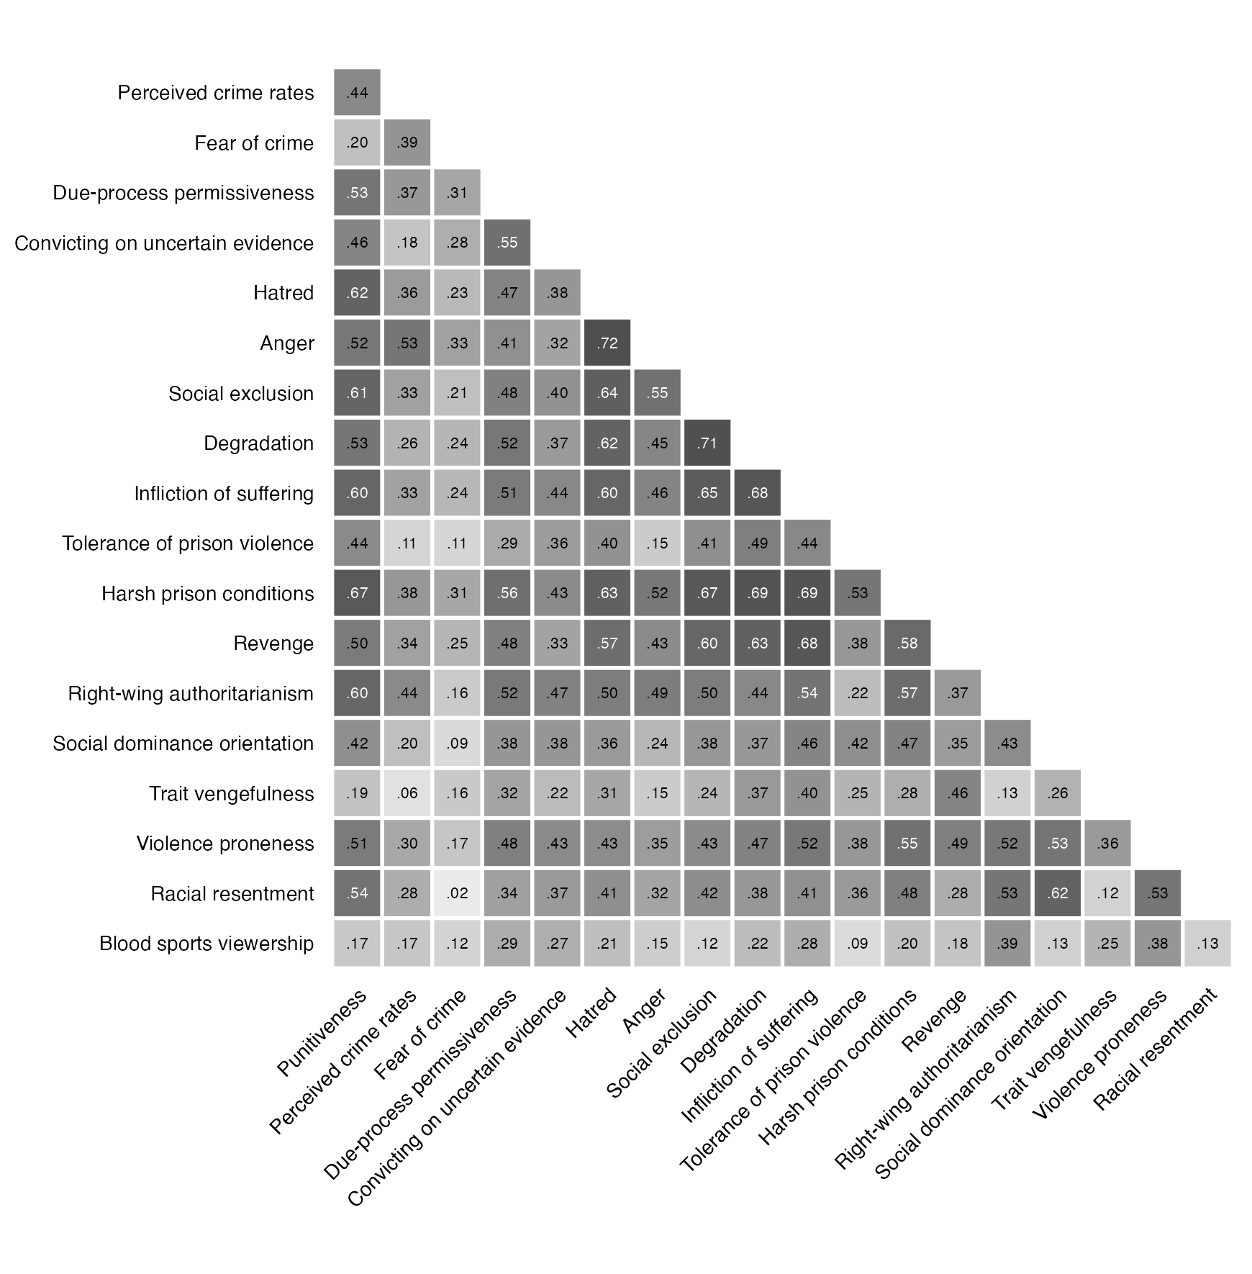
Note. Each cell gives the Pearson correlation of two measures; darker shading indicates a stronger positive correlation. The first column gives each correlate’s correlation with punitiveness (Table 1). The correlates are grouped by cluster: crime concerns, process violations, emotions, hostile aggression, and personality and ideology. The hostile aggression measures (social exclusion through revenge) form the tightest block of strong correlations. N = 496.

Moderation and Factor Structure
The correlations of punitiveness with each correlate were stable across the three vignettes: no correlate reversed direction in any vignette, and the median range of a correlate’s correlations across vignettes was .09 (Supplementary Materials, Section S1). The preregistered mixed-effects model with a random intercept for vignette estimated the variance between vignettes at zero, as the design leads one to expect: the sentence is standardized within vignette, and the other measures were answered before the vignette was shown. We tested whether age, gender, education, race, or political orientation moderated the relations of four key correlates (hostile aggression, crime concerns, right-wing authoritarianism, and racial resentment) with punitiveness (Table S2) and, in models that were not registered, with the sentence, holding punitiveness without the sentence (its five attitude components) constant (Table S3). Two tests were significant after correction, both with punitiveness as the outcome: crime concerns were more closely related to punitiveness among older participants, and hostile aggression was somewhat less closely related to it among more conservative participants. In a confirmatory factor model, all 16 correlates in the four clusters loaded positively on their factors, but three of the four global fit indices fell short of conventional thresholds. The clusters are therefore best understood as a way to organize the correlations, not as measures of one underlying attitude each (Supplementary Materials, Section S1).

Study 1 - Discussion
The central findings of this study are, first, punitiveness is surprisingly and closely associated with a host of psychological factors. Second, these factors are predominantly hostile. Including hatred, revenge, degradation, the endorsement of suffering (r = .59). The correlation with legitimate concerns about crime was, by comparison, rather weak, indeed it was weakest of our four clusters (r = .32). The emotions cluster correlated fairly strongly with punitiveness (r = .53). Among the constituent emotions, the strongest association was with hatred of convicted persons (r = .53). Unlike anger, hatred is a stable feeling that precedes and transcends particular events. Hatred has been labeled “our most dangerous emotion” (Brogaard, 2020) and is widely recognized as triggering the desire to coerce, exclude, harm, and humiliate its object (Bar-Tal, 2007; Fischer et al., 2018).
Punitiveness was also positively associated with the personality and ideology cluster (r = .47). The most prominent constituents were right-wing authoritarianism (r = .50) and racial resentment (r = .46), followed by social dominance orientation (r = .32). Punishment decisions thus reflect the punisher’s ideological and attitudinal commitments, which is particularly troubling with respect to the anti-egalitarian sentiments embodied by SDO and the racial prejudice embodied by racial resentment. These findings extend a long lineage of research highlighting the intimate connection between racism and criminal punishment (Armour, 2020; Bobo & Johnson, 2004; Chiricos et al., 2004; Unnever & Cullen, 2010).
The most striking finding is the prominence of the hostile aggression cluster, with a r = .59 correlation with punitiveness. Punitiveness was closely interrelated with hating people convicted of crimes, degrading them, inflicting suffering on them, tolerating physical and sexual assaults on them in prison, and exacting revenge on them. This profile reframes a classic claim about what punishment does for a society. Durkheim held that punishment binds a community together by reaffirming its shared values (see Garland, 1990). Our results suggest that the binding runs through shared aggression toward an out-group: the solidarity of those who punish is purchased at the expense of those who get punished. George Herbert Mead (1918) called this a “solidarity of aggression,” a conception recently revived as “hostile solidarity” by Carvalho & Chamberlen (2018) and Chamberlen & Carvalho (2019), and it fits Garfinkel’s (1956) account of punishment as a public ceremony of status degradation.

Study 2
Study 2 probes deeper into the justifications of punishment, focusing on retribution. Retribution holds an august position in the punishment discourse. It receives the lion’s share of scholarly attention and it occupies a central position in the politics of punishment (e.g., Moore, 1997; Murphy & Hampton, 1988; Tonry, 2011; von Hirsch & Ashworth, 2005). Retributive principles figure prominently in state criminal codes, in determinate sentencing regimes and in sentencing guidelines (von Hirsch, 2011; Whitman, 2003). As noted by Garland (2001) and Whitman (2003), the ascendence of retributivism since the 1970’s most likely easier for politicians and legislators to boost harsher punishment regimes.
Retribution looms large also within the human psyche. A sizable body of psychological research has shown that retribution plays a far more dominant role in affecting people’s punishment preferences than do the other justifications. In laboratory experiments, lay participants habitually endorse both retributive and utilitarian justifications of punishment, yet these stated preferences are often incompatible with actual punishment decisions. Specifically, people are found to be far more sensitive to the retributive features of the case (e.g., moral severity of the crime), than to deterrent (e.g., public profile of the crime, incidence of crime) or incapacitative goals (e.g., defendant’s preclusion from reoffending due to a disability). Participants are reluctant to punish for low levels of blameworthiness but are quite willing to punish for blameworthy acts in the absence of deterrent and incapacitative effects (Aharoni & Fridlund, 2012; Crockett et al., 2014; Carlsmith, 2008; Carlsmith & Darley, 2008; Carlsmith let al., 2002; Tetlock et al., 2007). At bottom, people are “intuitive retributionists” (Darley & Alter, 2013, 184; Twardawski et al., 2022). Indeed, as we find in the current study, our respondents are most likely to pick retribution as the strongest of the four justifications, to the tune of 39% of respondents.

The Five Features of Current Day Retributivism
Turning one’s sights onto the justification of retribution is no easy feat, as the steady stream of scholarly interest has defied a unitary formulation of the theory. As a consequence, the theory has come to mean different things to different people. Still, most current day retributivists will likely agree that some version of the following six features provide a fair account of their theory.
1. Following Imanuel Kant (1798), retributivism is a moral deontological theory that is grounded in respect for the dignity of the person being punished. Kant viewed the punishment of wrongdoers as a categorical imperative that was derivable from moral first principles and predicated on the respect owed to individuals as autonomous moral agents. In his words, “a human being can never be treated merely as a means to the purposes of another (Kant MM 104 [6:331]) [202]). He deemed all other principles of punishment as “fluctuating and unsuited for a sentence of pure and strict justice because extraneous considerations are mixed into them…” (MM 104, 6:331). Along these lines, convicted persons—including those condemned to death—must be kept entirely free of “any maltreatment that would make an abomination of the humanity residing in the person suffering it.” (1798, ???; Tonry, Reader, 33). Predicating retribution on the concept of human dignity has been reiterated by virtually every proponent of the theory (e.g., Hegel, ???; Moore, 1978; Morris, 1968; Murphy, 1979). Fundamentally, retribution is about moral justice, not expedience (von Hirsch, 2009).
2. Central to retribution theory is the principle of proportionality, which serves as a measure of the intensity of punishment. Retribution theorists have long felt discomfort with Kant’s endorsement of jus talionis (eye for an eye, tooth for a tooth), whether for conceptual, practical, or aesthetic reasons. In its stead, retributivists proposed the principle of proportionality or ‘commensurate deserts,’ by which the severity of the penalty ought to be set in proportion to the gravity of the criminal conduct. Its vagueness notwithstanding, proportionality has captured a consensus position in desert theory as evidenced in the writings of virtually every desert scholar (e.g., Morris, 1968; von Hirsch, 2017; von Hirsch & Ashworth, 2005). Indeed, a book-length volume of essays was triggered by the quest to ponder the future of retribution given that much of recent punishment p0licy—from draconian recidivism statutes to lenient drug courts—are inconsistent with proportional punishment (see Tonry, 2011).
3. Retributivists generally deem their framework as more lenient than their consequentialist counterparts. Retributivists have famously protested that utilitarianism could condone punishing the innocent if doing so would serve a utilitarian goal (a prospect repudiated by Rawls, 1955 and others). Retributivists also fear that when facing increasing crime rates, a utilitarian might advocate for continuing to increase the level of punishment limitlessly (von Hirsch, 2017). In contrast to such freewheeling punishment, retributivists tout the principle of proportionality as an effective tool to thwart any such excesses, thus viewing their theory as militating in favor of moderation (von Hirsch & Ashworth, 2005). It is notable that the retributivist revival that emerged in the 1970’s was led by mostly liberal, not conservative, theorists (von Hirsch, 2017).
4. Given that desert is triggered by a determination of legal guilt, the certainty of the defendant’s guilt takes on special importance as a condition for exacting retribution. Kant (1798) himself insisted that punishment should be exercised only following a fair trial. Again, distinguishing themselves from the putative amenability of consequentialists to punish the innocent, has led retributivists to hitch themselves to a vigorous insistence on the certainty of guilt. As stated flatly by Morris (1968): “only the guilty may be punished.”
5. From its very inception, retribution theory has claimed to transcend any psychological impulses that the punisher might experience. Kant, for one, went to great lengths to separate punishment from any form of human passion. He deemed it a “duty of virtue…to refrain from repaying another’s enmity with hatred out of mere revenge … because no punishment, no matter from whom it comes, may be inflicted out of hatred” (MM6: 460-61). Instead, Kant made punishment an act of pure intellect. He grounded punishment of wrongdoers in terms of a categorical imperative derivable from moral first principles, and analogizing the reciprocation of punishment to the physical “law of the equality of action and reaction” (6:232-3).
Kant is far from alone in defending retribution against the suspicion of boiling blood. Herbert Morris (1968) characterizes retaliation and revenge as “bringing about evil for another” [149], and insists that retribution has nothing to do with it. Joel Feinberg (1989) cautions against confusing retributive theory with vindictive satisfaction, attributing the latter to the “uneducated” class. By contrast, he explains that retributivists—presumably, philosophers and intellectuals—have been “among the leading enemies of vengeance” (p. 348). Robert Nozick (1981) begins his defense of retribution with the claim that it is not merely a “disguise for revenge” (p. 382). He contrasts seeking pleasure in the suffering of another with retribution which “either need involve no emotional tone, or involves another one, namely, pleasure at justice being done” (1981: 367). George Fletcher carries the metaphor into the realm of romance, explaining that retributivism “is not to be identified with vengeance or revenge, any more than love is to be identified with lust” (2000: 417).
In all, retributivists heap a great deal of praise on their creed, deeming their theory to be the most humanistic, measured, lenient, precise, and dispassionate. All of this leads retributivists to anoint retribution as the superior justification of punishment (e.g., Duff, 2011). Early in his career, Jeffry Murphy (1979) concluded that retributivism “is the only morally defensible theory of punishment." Yet, critical voices have persisted in viewing retributive punishment as entangled with motives borne by hostile emotions, particularly revenge and hatred (Finckenauer, 1988; Gerber & Jackson, 2013; Jacoby, 1983; McKee & Feather, 2008; Murphy, 2011; Okimoto et al., 2012; Vidmar, 2000). As Danielle Allen (2000) notes, the notion of just deserts always invokes the worry that “retribution is too close to revenge and its ugliness in tone, purpose, and effect.”
Thus, we have been stuck for some time at an impasse between two rivaling conceptions that have been coined retributivism as just deserts, and retributivism as revenge (Gerber & Jackson, 2013; Jacoby, 1983; Vidmar, 2000). Jeffry Murphy (2011) has labeled this dialectic The Two Faces of Retribution, with one face stressing “moral desert…human dignity and responsibility, and another face that tempts us to self-deceptive cruelty.” Trying to sort out this tension is a central focal point of this study. In this vein, we set out to examine differences between retributivist respondents and non-retributivist respondents on a host of measures relating to emotions, beliefs, motivations, punitiveness, and more. The hypothesis against which we will compare our results is that retributivists are true to their creed. That assumption would lead one to expect that their attitudes, beliefs, emotions and motivations would reflect the five normative principles that define contemporary retributivist theory.

Study 2 Methods
Study 2 was preregistered on the Open Science Framework (osf.io/u97xs).
Going into this project, we were aware of the abovementioned literature on intuitive retributivism which exposes the difficulties people encounter in reporting their true motivations for punishment. As shown repeatedly by Carlsmith, Darly, Aharoni, Crocket, and colleagues, people have only limited insight into the factors that motivate their punishment decisions (). When asked in the abstract, people typically support all three prominent justifications of punishment (retribution, deterrence, incapacitation), but when facing punishment decisions that require trading off one justification against the other, they exhibit strong fidelity to retribution ().
We were also cognizant of research that shows the limits asking single-shot questions on abstract issues. To partially remedy that, we presented the forced choice task only after having participants respond to seventeen questions that probed them on the central features of the four rivaling justifications (plus the Durkheimian concept of social solidarity). This exposure was designed to sensitize participants to the strengths and weaknesses of each of the justifications.
It is important to keep in mind that retributivists are not in one voice when it comes to applying their theory of moral justice. Positive retributivists posit that legal guilt is a sufficient reason to punish (e.g., Kant, 1798; Moore, 1987) whereas negative retributivists maintain that it serves merely as a necessary condition for the exercise of punishment (e.g. von Hirsch & Ashworth, 2005). We included measures that gauge both of those conceptions.

Participants
Adults living in the United States were recruited through Prolific’s representative sample, as in Study 1, and completed the survey in Qualtrics between July 2 and July 23, 2026. Participants had to be fluent in English, hold a Prolific approval rating of at least 95%, and not have taken part in Study 1. No Prolific ID appears twice among the analyzed responses, and none appears in the Study 1 data. Consent and institutional approval were as in Study 1, and participants were paid through Prolific.
The registered target was 960 complete and valid responses, twice Study 1’s target of 480. The larger sample was chosen to give power within the retributivist group, where H11 and H12 are tested and H2 and H10 are repeated, and for the comparisons of that group with the other participants (H13 to H21). With 960 participants, a two-sided test at α = .05 has 80% power to detect a correlation of .09 and, for a 35-to-65 split into groups, a standardized mean difference of 0.19; Section S2 of the Supplementary Materials gives the power within the retributivist group.
Of 1,015 responses, 50 were incomplete. Of the 965 complete responses, 7 failed the first attention check and 10 failed the second, both worded as in Study 1; no one failed both. The analyzed sample is 948, 12 short of the target; recruitment was not extended to make up the difference. As preregistered, completion time and runs of identical answers were examined, and neither led to an exclusion (Section S2).
Participants averaged 45.7 years of age (SD = 16.0, range 18–84); 51.6% were women, 47.6% were men, and 0.8% chose another category. Asked to choose one of seven categories, 65.8% identified as White and non-Hispanic, 15.1% as Black or African American, 9.1% as Hispanic or Latino, 7.0% as Asian, and 3.1% as Native American, Middle Eastern, or Pacific Islander. On a 7-point liberal–conservative scale, 43.0% placed themselves on the liberal side (1–3), 22.4% at the midpoint, and 34.6% on the conservative side (5–7). Section S2 gives party identification and education.

Procedure and Measures
Study 2 is a correlational survey in which, as in Study 1, only the crime vignette differed between participants. It repeats Study 1’s information sheet, instructions, and measures other than trait vengefulness and blood sports viewership, and adds new measures. Changes of wording are noted below. Unlike Study 1, which opened with the punitiveness items, Study 2 opened with the goals of punishment. This ordering was intended to prevent the attitudes towards the goals of punishment (the focal point of this study) from being impacted by the punitiveness measures.
Participants completed twelve blocks in a fixed order, described here in that order, and could not return to an earlier screen. Within each block of rating items, items appeared in a new random order for each participant. Unless noted, items were rated on Study 1’s 7-point agreement scale, and each measure is the mean of its items after reverse coding. Every rating item required an answer, so no rating measure has a missing value.
Goals of punishment (Block 1). Participants first rated 17 statements about the goals of punishment: retribution (seven items), deterrence (three items; e.g., “Punishment is justified because it deters others from committing crimes”), incapacitation (two items; e.g., “Society is safest when criminals are locked behind bars”), rehabilitation (two items; e.g., “Prison programs can make prisoners become productive members of society”), and solidarity (three items). Five of the seven retribution statements, the desert-theory items, are scored as their mean (desert theory), with two capturing a harder version of retribution theory (“Justice requires that crimes be punished” and “The state has a duty to punish its criminals”) and three capturing a softer version of retribution (“Society has a moral right to punish criminals,” “Justice is restored when criminals are punished,” and “Punishment is justified because criminals deserve to be punished”). The two sets are also scored separately. The remaining two retribution statements give rationales for punishing (repaying a debt to society and negating an unfair advantage over law-abiding citizens) and enter only the seven-item retribution subscale, from which relative retribution is computed (see Identifying the Retributivists). Deterrence, incapacitation, and rehabilitation are each the mean of their items. Durkheimian solidarity averages the two solidarity items stating that punishing brings the law-abiding together and that it expresses society’s norms; the third (“Removing criminals from society helps society cleanse itself”) was set aside, as preregistered, because it seems to read more as a measure of social exclusion rather than Durkheimian solidarity.
On the next screen, participants ranked four reasons for punishment from “the best reason” to “the weakest reason” by placing them in a hierarchical order: “Criminals deserve to be punished,” “Punishment deters others from committing crimes,” “While they are locked up, prisoners cannot commit other crimes,” and “Prisoners get rehabilitated in prison.” The four choices appeared in random order, beneath a prompt that listed them in this fixed order. Participants were then asked to explain their ranking in writing; an answer was not required, and the answers that were given will not be analyzed here.
Punitiveness (Block 2). Participants then answered Study 1’s eight punitiveness items, with the first attention check at a random position among them. Punitiveness has Study 1’s six components and is scored as in Study 1, with the first recommended sentence (Block 10) as the sixth: each component is standardized, and punitiveness is their mean. Wherever an analysis relates punitiveness Sentence 1:to the first sentence or to a measure built from the two sentences (see Identifying the Retributivists), punitiveness leaves the sentence out, as the preregistration requires for the sentencing ratio (Sections 5.3 and 5.11): it is the mean of the five attitude components, each standardized, rather than the eight-item scale the preregistration names.
Revenge and proportionality (Block 3). Four revenge items were presented: Study 1’s three (the third reworded to say “sexually assaulted” where Study 1 said “raped”) and a fourth, “Rather than showing criminals so much tolerance, we should be punishing them more severely.” Revenge is the mean of the four. Three items concerned proportionality. The proportionality principle is the direct item, “Punishment should be proportionate to the severity of the crime, no more and no less.” The other two concern departures from it: “Punishment should be greater than the seriousness of the crime” and “Punishment should be less severe than the harmfulness of the crime.” Their mean, with the second reversed, is the severity index, on which a high score means punishment at or above the offense and never below it. The index combines two distinct judgments, so no reliability is reported for it, and each item is also reported alone. The preregistration also combines all three items, with both departures reversed, into a proportionality component; that combination is reported only in the Supplementary Materials.
Exclusion, essentialism, and choice (Block 4). This block measured social exclusion (Study 1’s three items), essentialism about offenders (four items, one reversed; e.g., “Once a criminal, always a criminal”), rejection of society’s responsibility for crime (three items, all reversed, so that a high score means rejecting that responsibility; e.g., “The state should take better care of people so that they will choose not to commit crimes”), and the belief that crime is a choice (two items; e.g., “Committing a crime is always a choice”).
Due process (Block 5). Participants answered Study 1’s items on due-process permissiveness and convicting on uncertain evidence, with the second attention check at a random position among them.
Crime concerns, emotions, and harshness (Blocks 6 to 8). These blocks repeated Study 1’s items and response scales for perceived crime rates and fear of crime (Block 6); hatred of offenders and anger (Block 7); and degradation, infliction of suffering, tolerance of prison violence, and harsh prison conditions (Block 8).
Personality and cognitive reflection (Block 9). Four of Study 1’s scales followed in random order: right-wing authoritarianism, social dominance orientation, violence proneness (the closing question of its last item, “To what extent do you agree with pursuing that course of action?”, reworded as “To what extent do you agree with dropping the nuclear weapon on the enemy’s capital?”), and racial resentment. The Cognitive Reflection Test (Frederick, 2005) came next. Its three items were answered on sliders, and answers were not required. The score is the number of correct answers to the first two items (the bat-and-ball and widgets problems). The slider for the third (lily-pad) item was labeled in minutes although the answer, 47, is in days; the registered score, which counts all three, is reported in the Supplementary Materials. Three participants left the first item blank and have no score.
Sentencing (Block 10). Qualtrics assigned each participant at random to one of Study 1’s three vignettes, keeping the groups balanced. Vignette A omitted Study 1’s description of the victim as a teacher. The sentencing instructions were Study 1’s, except that participants were asked what punishment they “recommend for Darryl’s crime,” where Study 1 asked what punishment Darryl “deserves.” Participants set a first sentence on Study 1’s slider. The next screen asked them to “assume that Darryl recently contracted a severe autoimmune disease that has permanently paralyzed his limbs” and that, “[a]ccording to the state’s expert testimony, he no longer poses a threat to society.” It also asked them to assume “that state law imposes strict confidentiality on all cases involving minors under the age of 18, and that Frankie was 17.5 years old at the time the case was filed,” so that “the crime that Darryl committed and the punishment he receives will never be made public.” The added facts were written to remove incapacitation and deterrence as reasons to punish: an offender who poses no threat need not be confined, and a punishment that is never made public neither deters others nor expresses society’s norms. Under these facts, punishment can be justified on little ground other than retribution, although the facts do not address rehabilitation directly. With the first sentence no longer shown, participants set a second sentence on the same slider. Participants then explained their sentence (an answer was required) and said what they hoped it would accomplish (an answer was optional), without being told which sentence the prompts meant. These answers and the explanations of the ranking are analyzed in a separate report.
Shark scenario (Block 11). Participants read about a fatal shark attack on a 10-year-old girl and the capture, two days later, of a live shark believed to be of the same species. They indicated whether they supported putting the shark to death (yes or no), how confident they were in that answer (not reported here), and, assuming the authorities put it to death, how painful its death should be (1 = not painful at all, 7 = very painful).
Demographics (Block 12). Age, gender, race and ethnicity, education, and the liberal–conservative item were followed by party identification and two items on leaning toward the prosecution: whether participants identified more with the prosecutor or the defense attorney in a criminal trial, and which of those roles they would rather serve. Answers were coded +1 for the prosecution, −1 for the defense, and 0 for about the same. Prosecution leaning is their mean and runs from −1 to +1.

Identifying the Retributivists
As mentioned, people’s reasons for punishing are difficult to elicit. Asked in the abstract, people endorse the utilitarian goals of punishment as well as retribution (Carlsmith, 2008), yet their punishment judgments track the seriousness of the offense and are largely insensitive to the factors on which deterrence depends (Carlsmith et al., 2002). Ratings of each goal therefore say little about people’s preferred goal of punishment. As preregistered, the primary categorical definition of retributivism is the forced ranking, which makes participants trade the four goals off against one another: the retributivists are the participants who ranked “Criminals deserve to be punished” first. To make sure that participants had considered all goals before ranking them, the ranking was presented only after they had responded to the 17 goal items.
Relative retribution, the registered primary continuous measure, is the seven-item retribution subscale minus the mean of the deterrence, incapacitation, and rehabilitation subscales. It captures placing retribution ahead of the other goals rather than endorsing every goal. For group contrasts it is split at the median and cut into top and bottom thirds, groupings that are secondary to the ranking.
The third measure is behavioral. Because the facts added before the second sentence leave little ground for punishing other than retribution, the share of the first sentence that a participant keeps indexes reliance on retribution. This sentencing ratio divides the second sentence by the first, for participants whose first sentence was above zero. For group contrasts, participants who kept or raised the sentence are compared with those who reduced it. As registered, the second sentence residualized on the first serves as a check on the ratio.
The analyses thus use four groupings (the ranking, the median split, the thirds, and the sentencing-ratio split) and four continuous measures (relative retribution, the seven-item retribution subscale, the sentencing ratio, and the residualized second sentence). A ranking records which goal comes first, not how strongly it is held, and a kept sentence can reflect any reason to punish that survives the added facts, so the measures are treated as convergent rather than interchangeable. Participants at each cutpoint were assigned to a group by rules set in the analysis (Section S2). The preregistration’s fourth, exploratory measure, retributive language in the open-ended answers, is not used here.

Analytic Strategy
Five scorings and one comparison depart from the preregistration or settle a choice it left open. Desert theory is scored from the five desert-theory items rather than the four registered desert items, which leave out the item on the state’s duty to punish. The preregistration states H7, H9, and H10 in terms of just deserts, whose two parts are that punishment is deserved and that it is proportionate (Section 5.4). Just deserts is scored as the mean of desert theory and the proportionality principle, and H7, H9, and H10 are reported against both just deserts and desert theory alone. Scoring the two parts as one departs from the preregistration, which provides that they are not forced into one score if they do not hold together (Section 5.4), as H6 predicts they do not. In the registered versions, reported in the Supplementary Materials, just deserts is the mean of the four registered desert items and the three-item proportionality component; the preregistration names the two parts without a rule for combining them. H6 is assessed through the proportionality principle and the severity index rather than the three-item proportionality component. The Cognitive Reflection Test is scored from two items. Punitiveness weights its six components equally and includes the first sentence except where an analysis relates it to that sentence or to a measure built from the two sentences, where it is the mean of the five attitude components. The preregistration builds punitiveness as in Study 1 and names the versions with and without the sentence but does not assign the tests to either (Section 5.2), although its summary table calls the version without the sentence its central measure (Appendix A). Section S6 of the Supplementary Materials repeats the main analyses with the eight-item scale and the sentence each given half the weight. Retributivists are compared not with all other participants, as preregistered (Section 6.5), but with the participants who ranked deterrence or incapacitation first, a stricter test that leaves out those who ranked rehabilitation first. The registered versions are reported in the Supplementary Materials, and Table S5 lists them with the other departures from the preregistration and the analyses added after it; each addition is marked where it is reported.
Predictions that name a direction were tested one-sided in that direction and the others two-sided, at α = .05. Analyses that were not registered are two-sided unless they rerun a registered test, in which case they keep its direction. Confidence intervals are two-sided 95% intervals, so a one-sided test can reach significance while its interval includes zero. Associations are Pearson correlations. Two correlations that share a variable (in H2, E2, H6, and H10, and with the sentencing ratio) were compared with Steiger’s (1980) test and Zou’s (2007) interval for their difference.
H1 relates punitiveness to twelve registered correlates: Study 1’s correlates other than the six measures of personality and ideology. For H2 the preregistration drew two clusters from them, hostile aggression (hatred, revenge, degradation, infliction of suffering, and tolerance of prison violence) and crime concerns (perceived crime rates and fear of crime), without saying how their members are combined. Each cluster is the mean of its standardized members, a choice made in the analysis. Study 1 averaged the raw items of its clusters, and its hostile aggression cluster included social exclusion and harsh prison conditions and left out hatred. Whether the correlates form one dimension (H3) was assessed from the share of positive intercorrelations, the eigenvalues of their correlation matrix, and a one-factor exploratory factor analysis. E2 compares the correlation of punitiveness with Durkheimian solidarity against its correlation with social exclusion, the registered measure of hostile solidarity.
Agreement with the proportionality principle was compared with the scale midpoint by a one-sample t test (H4), and paired t tests compared the two departures from proportionality (H5) and endorsement of desert theory and of just deserts with that of revenge (H9). H6 predicts that the two parts of just deserts, that punishment is deserved and that it should be proportionate, do not hold together. It is assessed from the correlation of desert theory with the proportionality principle, compared with its correlation with the severity index. H7 and H8 concern due-process permissiveness, convicting on uncertain evidence, hatred, and anger, each scored so that a high score is the less restrained answer. H7 correlates them with revenge, with desert theory, and with just deserts, and H8 with punitiveness. The predicted correlations with revenge and with punitiveness are positive and were tested one-sided; the predictions of no relation to desert theory and to just deserts were tested two-sided. The preregistration confines H7 and H8 to these measures because the others it names for H7 (degradation, infliction of suffering, and tolerance of prison violence) belong to the hostile aggression cluster (Section 5.5). An unregistered composite averages the four standardized scores, and a second leaves out hatred, which also belongs to that cluster. H10 compares the correlation of revenge with punitiveness against those of desert theory and of just deserts. Sections S2 to S4 of the Supplementary Materials give the details of these tests.
The registered contrasts, reported here against the participants who ranked deterrence or incapacitation first, compare retributivists on the hostile aggression cluster and ten of the H1 correlates (H13), the first sentence standardized within vignette (H14), the rated pain of the shark’s death (H15), essentialism (H16), crime as a choice (H17), prosecution leaning (H18), rejecting society’s responsibility (H19), due-process permissiveness and convicting on uncertain evidence (H20), and punitiveness (H21). They were tested with Welch’s t test and summarized by Cohen’s d. For each continuous measure of retributivism, the standardized outcome was regressed on the standardized measure, and the slope (β) is reported with its 95% confidence interval. H15 also covers the yes-or-no shark decision, analyzed by logistic regression. As registered, each contrast is reported under every grouping and continuous measure, except that the sentencing ratio is not used with the first sentence as the outcome (H14). The residualized second sentence is not used with that outcome either, and the shark decision is not modeled on it (Table S5).
H11 repeats H1 to H10 within the retributivist group. H12 describes, within that group, the share endorsing each hostile attitude (a mean above 4, the scale midpoint) and each attitude’s correlation with punitiveness, tested two-sided because H12 names no direction. Both are repeated on the retributive side of the other three groupings. Shares have exact (Clopper–Pearson) intervals. The preregistration asks for the agreement among the groupings but names no statistic. Agreement is reported as the share of participants whom two groupings classify alike, beside the share expected by chance, as Cohen’s κ, and by comparing the ranking groups on relative retribution and on the sentencing ratio.
Only the H1 correlations were corrected for multiple comparisons, with the Benjamini–Hochberg procedure (Benjamini & Hochberg, 1995) applied separately to each set of twelve, in the whole sample and on the retributive side of each grouping. The preregistration applies the correction where “a set of related correlations is tested together, as in H1” (Section 6.1), which we read as naming the H1 set. It calls for no correction of the group contrasts.
The personality and cognitive reflection contrasts (E1), the comparison of the two forms of solidarity (E2), the factor structure of the correlates (reported with H3), and the change from the first sentence to the second as a function of retributivism are exploratory, as registered. The preregistration also names political orientation and prosecution leaning as exploratory moderators (Section 6.6); those models are reported in Section S5 (Table S23).
Study 2 used the same versions of R, psych, cocor, and lavaan as Study 1: psych for reliability, the exploratory factor analysis, and κ; cocor for Steiger’s test and Zou’s interval; and lavaan for the registered factor model of H6. Cohen’s d with its interval used effectsize 1.0.2 (Ben-Shachar et al., 2020).

Study 2: Results
Like Study 1, Study 2 was preregistered. Part 1 asks whether the Study 1 pattern appears again in a new and larger sample; Parts 2 and 3 extend the work to examine psychological dimensions of the retribution justification in particular. Our terminology should be made as clear as possible, as we distinguish between four terms: revenge, support for vengeance against offenders, is one of the hostile aggression measures. Retribution is the broad view that wrongdoing deserves punishment. Desert theory is the mean of the five desert-theory items, and just deserts is the composite of desert theory and the proportionality principle. The analyses use the scorings described in the Method section. The registered scorings are reported in the Supplementary Materials, and we report in the article where they lead to a different conclusion.

Part 1: Replicating the Study 1 Pattern

Sample, reliability, and the sentencing decision
In Table S4, α ranged from .54 (degradation) to .91 (racial resentment and desert theory), apart from the registered proportionality component (α = .24). In a correlation that was not registered, the two desert-theory items stating that crime must be punished (positive retribution) and the three stating that punishment is permitted, is justified, or restores justice (negative retribution) correlated r = .837, 95% CI [.817, .855]; the five items are analyzed together. Four of the twelve registered correlates fall below α = .70 (degradation, due-process permissiveness, tolerance of prison violence, and convicting on uncertain evidence), so their correlations are attenuated by measurement error.
The mean sentence, 36.2 years (SD = 12.8, Mdn = 35), was 11.2 years above the 25-year midpoint of the range given in the instructions, t(947) = 26.99, two-sided p < .001, d = 0.88, in a test that was not registered. The 50-year maximum was chosen by 38.0% of participants (Figure 4). The 948 participants, a sample separate from Study 1’s, were divided among Study 1’s three vignettes as 315, 317, and 316, and the median participant finished in 22.7 minutes (interquartile range 17.4–30.0).

Figure 4
First Sentences in Study 2
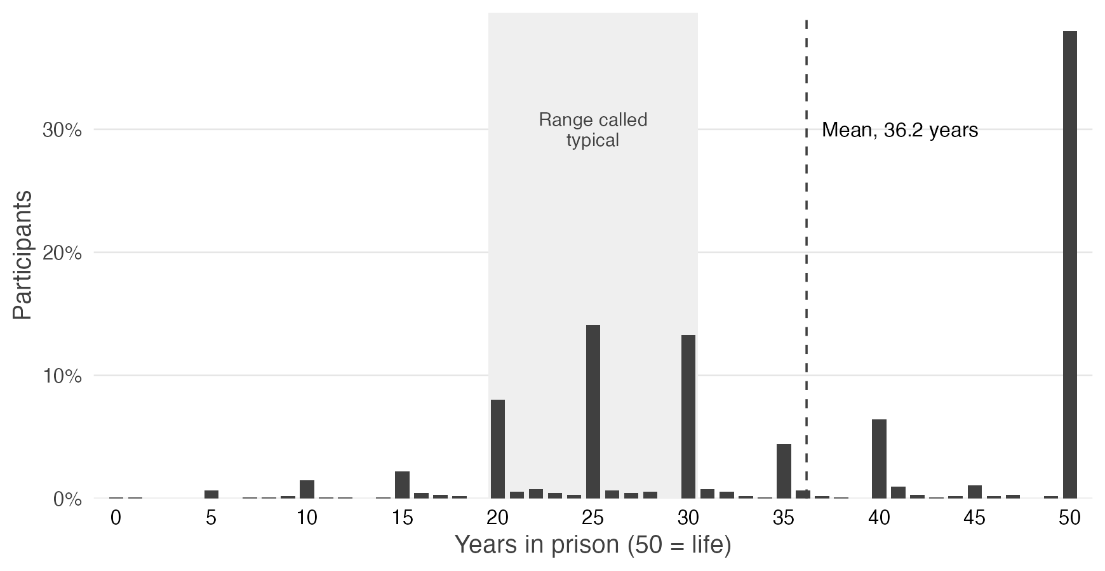
Note. Bars show the percentage of participants who chose each first sentence, in whole years from 0 to 50 (50 = life). The shaded band marks the 20-to-30-year range that the instructions described as typical for similar charges, and the dashed line marks the mean, 36.2 years; 38.0% of participants chose the 50-year maximum. N = 948.

Punitiveness is related to all twelve registered correlates (H1)
As Hypothesis 1 predicted, punitiveness correlated positively with all twelve registered correlates, and all twelve correlations remained significant after Benjamini–Hochberg correction of one-sided tests (Figure 5; Table S6). The largest were with harsh prison conditions, r = .680, 95% CI [.644, .713]; revenge, r = .676 [.640, .709]; and hatred, r = .662 [.624, .696]. The smallest was with fear of crime, r = .236 [.175, .295].

Figure 5
Correlations of Punitiveness With the Twelve Preregistered Correlates in Study 2 (H1)
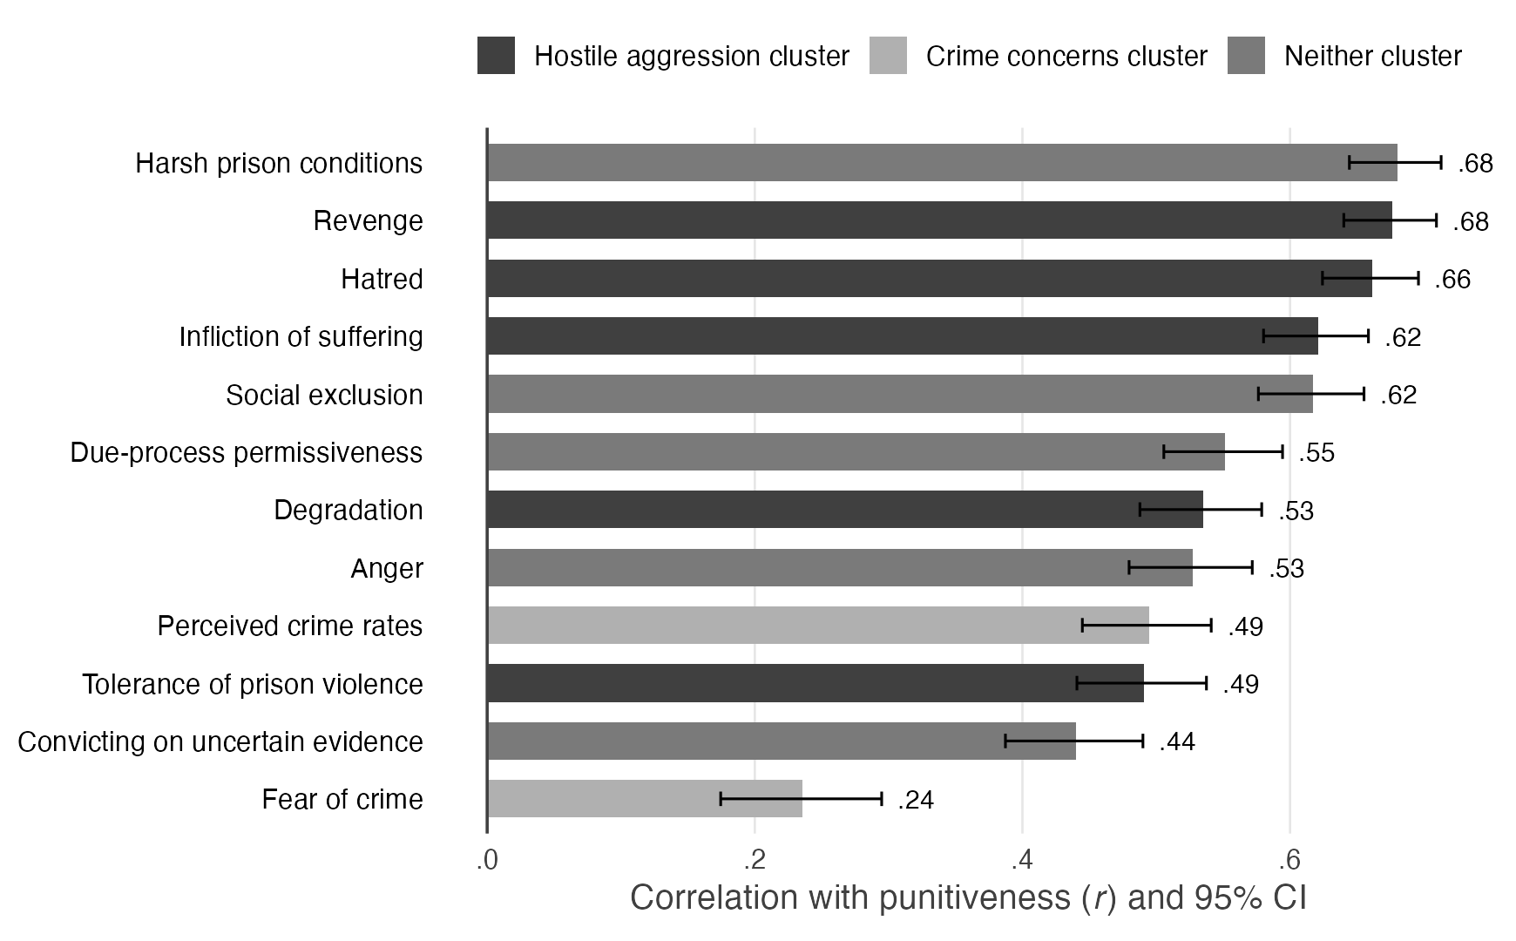
Note. Bars show each correlate’s correlation with punitiveness (its six components weighted equally), with 95% confidence intervals. Shading marks the preregistered H2 cluster to which each correlate belongs (hostile aggression: hatred, revenge, degradation, infliction of suffering, and tolerance of prison violence; crime concerns: perceived crime rates and fear of crime); the other five belong to neither cluster. Tests are one-sided in the preregistered direction, with Benjamini–Hochberg correction across the twelve; all twelve correlations are positive and remain significant after correction. Table S6 gives every value, beside the correlations with the two other versions of punitiveness that the preregistration names. N = 948.

Punitiveness tracks hostility more closely than crime concerns (H2)
Punitiveness was more closely related to hostility toward offenders than to concern about crime, supporting Hypothesis 2. It correlated r = .749 with the hostile aggression cluster and r = .427 with crime concerns. The difference, the hostile aggression advantage (hereafter, the hostility advantage), was ∆r = .322, 95% CI [.269, .377], Steiger’s Z = 12.51, one-sided p < .001. In analyses that were not registered, the advantage held under every other construction of the clusters tested (Supplementary Materials, Section S3). The comparison is relative: crime concerns, measured as perceived crime rates and fear of crime, are themselves substantially related to punitiveness.
The Study 1 pattern replicated in comparisons that were not registered, with the measures scored as in Study 1. The sixteen correlates measured in both studies fell in nearly the same order (Spearman ρ = .93), and the four clusters fell in the same order. The hostility advantage held at each of Study 1’s three levels of strictness (with all six of Study 1’s measures, ∆r = .357, 95% CI [.303, .414]; Study 1, .331) and on each of the six components of punitiveness, including the sentence. Because Study 2’s clusters differ from Study 1’s in membership and scoring (see Method), H2 is a conceptual replication. The replication claim concerns the pattern and its ordering, not the size of individual correlations (Supplementary Materials, Section S3).

Punitiveness tracks social exclusion more closely than Durkheimian solidarity (E2)
E2, registered as exploratory and without a counterpart in Study 1, predicted that punitiveness would relate more strongly to hostile solidarity, measured by social exclusion, than to Durkheimian solidarity. The prediction held. Punitiveness correlated r = .617 with social exclusion and .519 with Durkheimian solidarity (the two measures correlated .504 with each other); the difference was ∆r = .098, 95% CI [.049, .148], Z = 3.94, one-sided p < .001.

The correlates are positively intercorrelated (H3)
As Hypothesis 3 predicted, the correlates were positively intercorrelated: all 66 correlations among the twelve were positive, ranging from r = .049 to .705. One dimension dominated this structure but did not exhaust it. The first eigenvalue of the correlates’ correlation matrix, 5.95, accounted for 49.5% of the variance; the second, 1.34, accounted for 11.2% and also exceeded 1; the remaining ten fell below 1. In a one-factor exploratory factor analysis, which accounted for 45.5% of the variance, all twelve correlates loaded positively, from .35 (fear of crime) to .83 (harsh prison conditions). This pattern, and not a claim that the correlates measure a single theme, is what we mean by a punitive mindset.

Part 2: What People Mean by Retribution
Part 2 uses the whole sample, and none of its tests is corrected for multiple comparisons. Desert theory is the mean of the five desert-theory items, and just deserts is the mean of desert theory and the proportionality principle (see Method).

Retribution was ranked first most often, and second most often last
Retribution was the goal of punishment most often ranked first, and the second most often ranked last (Figure 6). It was placed first by 371 of 948 participants (39.1%), ahead of incapacitation (28.1%), deterrence (19.7%), and rehabilitation (13.1%), and last by 21.6%, behind only rehabilitation (56.0%). On the rating scales, where participants did not have to choose among the goals, all four were rated above the midpoint of 4: incapacitation (M = 5.61), retribution (5.60, measured by desert theory), and deterrence (5.50) close together, and rehabilitation (4.52) lower. These figures are descriptive: no hypothesis concerned them, and no difference between goals was tested. The 39.1% should be read with three limits in mind: the ranking records only order and forces a choice; its four options are not parallel statements; and the prompt above them listed retribution first, so a primacy effect cannot be ruled out (Supplementary Materials, Section S4).

Figure 6
Ranking the Four Goals of Punishment in Study 2
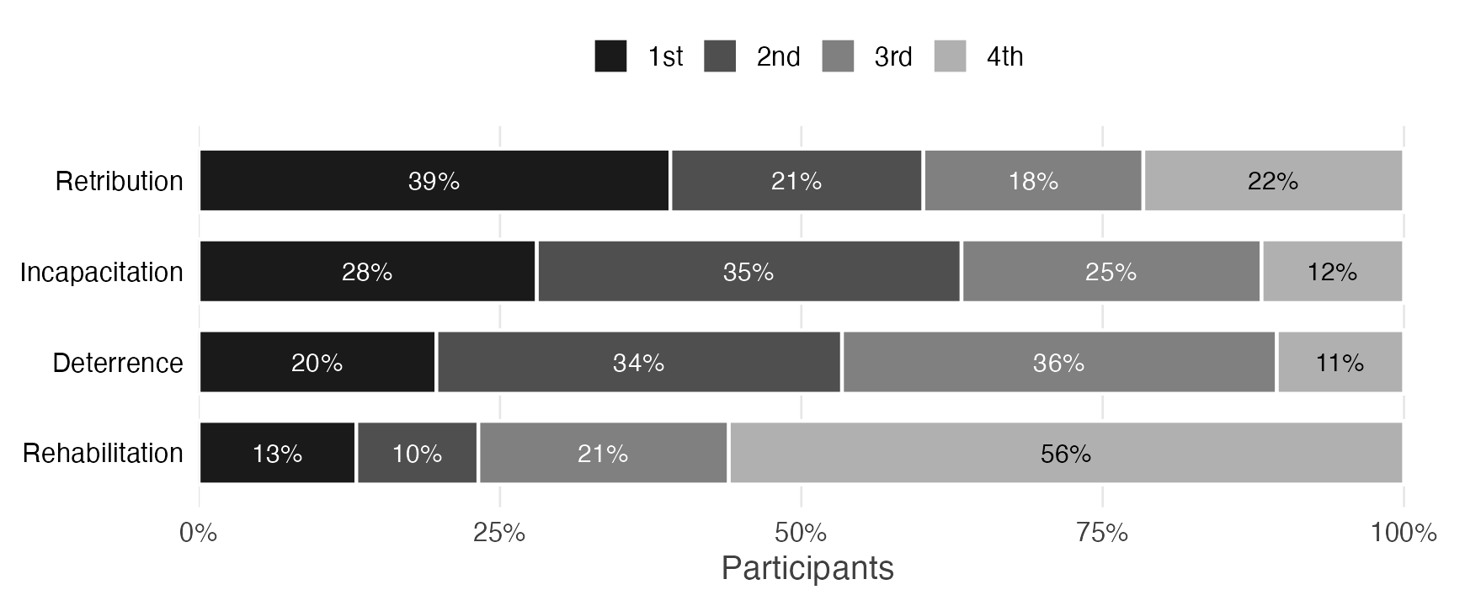
Note. Bars show the share of participants who placed each goal first through fourth when ranking four reasons for punishment from best to weakest. Ratings of the goals were collected before the ranking. Ranking options: “Criminals deserve to be punished” (retribution); “While they are locked up, prisoners cannot commit other crimes” (incapacitation); “Punishment deters others from committing crimes” (deterrence); “Prisoners get rehabilitated in prison” (rehabilitation). N = 948.

Proportionality is widely endorsed (H4 and H5)
Most participants, 83.1%, agreed with the proportionality principle, that punishment should be proportionate to the crime (Supplementary Materials, Figure S4). H4’s first claim, that agreement would sit at or below the scale midpoint, failed in the direction opposite to the prediction: agreement with the proportionality principle averaged M = 5.72 (SD = 1.36), t(947) = 38.80, d = 1.26, 95% CI [1.17, 1.35]; the registered one-sided test of a mean below 4 gives p = 1.00. H4’s second claim, that a sizeable share would endorse punishment beyond the seriousness of the crime, cannot be tested, because no criterion for a sizeable share was set; 25.5% [22.8, 28.4] agreed that punishment should be greater than the seriousness of the crime.
As H5 predicted, participants agreed more that punishment should be greater than the seriousness of the crime (M = 3.35) than that it should be less severe than the harmfulness of the crime (M = 2.70). The mean paired difference was 0.64, 95% CI [0.48, 0.80], t(947) = 7.98, one-sided p < .001, d = 0.26 [0.19, 0.32]. The difference is small, and both means lie below the midpoint: on average, participants disagreed with punishment beyond the crime, though less firmly than with punishment below it.

Desert theory goes with severity more than with proportionality (H6)
H6 predicted that the two parts of just deserts, that punishment is deserved and that it should be proportionate, would not hold together. In correlations that were not registered, desert theory went only weakly with the proportionality principle, r = .199, 95% CI [.137, .260], and more strongly with the severity index, r = .474 [.423, .522] (Figure 7). The difference was ∆r = .275 [.193, .356], Z = 6.53, two-sided p < .001, and the registered test, on the three-item proportionality component, also found that the two parts do not hold together (Supplementary Materials, Section S4). Punitiveness showed the same pattern more sharply, again in correlations that were not registered: r = .588 with the severity index against .038 with the principle.

Figure 7
Correlations of Desert Theory With the Proportionality Principle and the Severity Index in Study 2
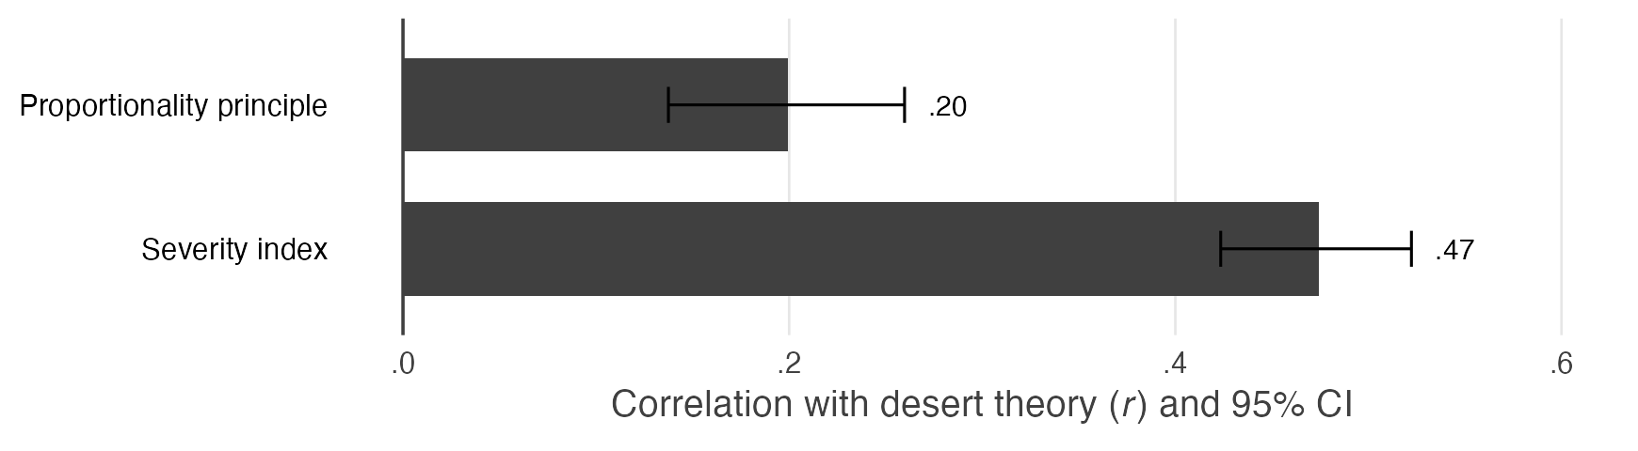
Note. Bars show the correlations of desert theory with the proportionality principle and with the severity index, with 95% confidence intervals. Neither correlation was registered; intervals are two-sided. Table S10 gives the same correlations for the registered desert score (items 1 to 4) and for punitiveness, and the correlations with each item of the severity index. N = 948.
Desert theory’s weak tie to its limiting factor, proportionality, is not peculiar to it (Figure 8). In correlations that were not registered, deterrence and incapacitation correlated negatively with parsimony, the consequentialist limit that punishment be no heavier than necessary, r = −.395 and −.450. So did desert theory, r = −.463, whereas rehabilitation did not, r = −.045. All four goals correlated with the proportionality principle to much the same degree, r = .167 to .200. These correlations were not tested against one another (Supplementary Materials, Section S4).

Figure 8
Correlations of Each Goal of Punishment With the Limits on Punishment in Study 2
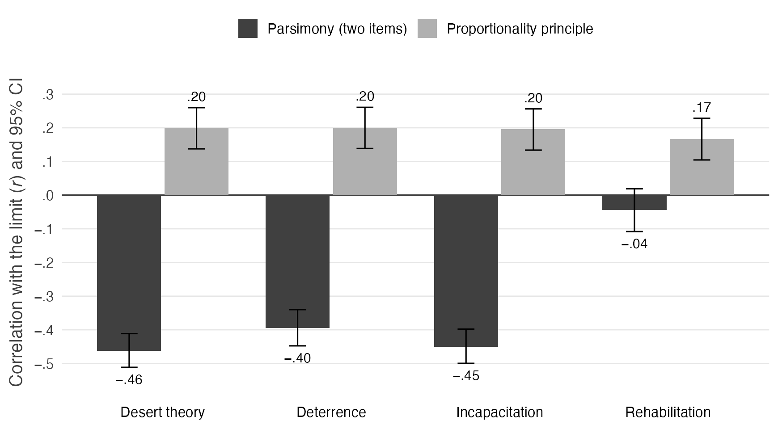
Note. Bars show correlations, with 95% confidence intervals, between each goal and parsimony (dark; both items scored so that agreement means accepting the limit) and between each goal and the proportionality principle (light). Retribution is measured by desert theory. None of these correlations was registered. Table S11 also reports the parsimony principle item alone, the three-item proportionality component, and the registered desert score (items 1 to 4). N = 948.

Desert theory, just deserts, revenge, and punitiveness (H9 and H10)
As H9 predicted, participants agreed much more with desert theory than with revenge: M = 5.60 against 4.14, a paired difference of 1.46, 95% CI [1.38, 1.54], t(947) = 36.22, one-sided p < .001, d = 1.18 [1.09, 1.26]. They also agreed more with just deserts (M = 5.66) than with revenge, a difference of 1.52 [1.43, 1.60], t(947) = 33.27, one-sided p < .001, d = 1.08 [1.00, 1.16]. Participants did not reject revenge, however; its mean sits near the neutral point of the scale.
H10 predicted that revenge would correlate more strongly with punitiveness than just deserts would. Against desert theory, revenge showed no advantage: the two tracked punitiveness equally, r = .676 [.640, .709] and .674 [.638, .708], ∆r = .002 [−.039, .042], Z = 0.09, one-sided p = .47. Against just deserts, revenge tracked punitiveness far more closely, r = .676 against .432 [.379, .482], ∆r = .244 [.188, .301], Z = 8.70, one-sided p < .001, as H10 predicted. The gap arises because the proportionality principle is essentially unrelated to punitiveness (r = .038), so averaging it into just deserts lowers just deserts’ correlation with punitiveness. The registered tests of H9 and H10, on the registered just-deserts score, reach the same verdicts as the tests against just deserts (Supplementary Materials, Section S4).

About half the sample kept its sentence
After participants learned facts meant to remove incapacitation and deterrence as reasons to punish (see Method), the mean sentence fell from 36.2 years to 29.4, but the sentencing ratio, computed for the 947 participants whose first sentence was above zero, had a median of 1.00 (Figure 9). In a grouping that was not registered, 479 participants (50.6%) kept their first sentence exactly, 279 of them at the 50-year maximum; among the 587 whose first sentence was above zero and below the maximum, 60.0% [55.9, 64.0] reduced it (Supplementary Materials, Section S4). In the registered one-sided analysis of the ratio as a continuous score, keeping more of the sentence went with revenge, β = .227 [.165, .289], and with punitiveness without the sentence (its five attitude components), β = .311 [.251, .372]; punitiveness leaves out the sentence here because the ratio is built from the sentences. In correlations that were not registered and are two-sided, the ratio correlated with desert theory about as strongly as with revenge, r = .225 [.163, .284] (∆r = −.002 [−.061, .056], p = .93), but not with the proportionality principle, r = −.004 [−.067, .060], p = .91.

Figure 9
The Second Sentencing Decision in Study 2
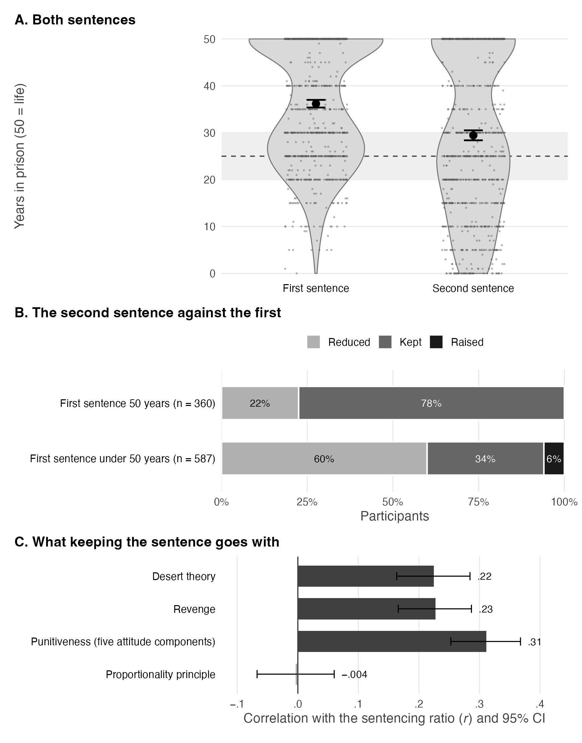
Note. Before the second sentence, participants learned that the defendant was permanently paralyzed and no longer a threat, and that the case would never be made public. Panel A shows the first and second sentences on the 0-to-50-year scale (50 = life): violins show the distribution, small points are individual participants jittered horizontally, and large points are means with 95% confidence intervals; the shaded band marks the 20-to-30-year range given in the instructions and the dashed line its midpoint. Panel B shows the share who reduced, kept, or raised the sentence, separately for participants whose first sentence was the 50-year maximum and for those below it; this grouping was not registered. Panel C shows correlations, with 95% confidence intervals, between the sentencing ratio and desert theory, revenge, punitiveness without the sentence (its five attitude components), and the proportionality principle. The correlations with revenge and punitiveness come from the registered analysis of the ratio; those with desert theory and the proportionality principle were not registered. Panel C’s Fisher intervals differ slightly from the text’s regression-based intervals for revenge and punitiveness. Panels B and C exclude the one participant whose first sentence was zero (n = 947).

Setting aside the limits on punishment (H7 and H8)
As H7 and H8 predicted, participants more willing to set aside the limits that the preregistration calls Kantian endorsed revenge more and were more punitive. Willingness to set these limits aside was measured by due-process permissiveness, convicting on uncertain evidence, and, for dispassion, its opposites, hatred and anger. Each of the four measures of these limits correlated positively with revenge, from r = .431 [.378, .482] to .627 [.587, .664], and with punitiveness, from r = .440 [.387, .490] to .662 [.624, .696], each one-sided p < .001. H7’s second prediction, that the limits would be unrelated to just deserts, failed: all four measures correlated positively with desert theory, from r = .359 [.303, .414] to .583 [.539, .623], and with just deserts, from r = .173 [.110, .234] to .337 [.279, .392], each two-sided p < .001. The prediction failed on the registered just-deserts score as well (Supplementary Materials, Section S4).

Part 3: The People Who Rank Retribution First
Under the preregistration’s primary definition, the retributivists are the 371 participants (39.1%) who ranked “Criminals deserve to be punished” first. They are compared here with the 453 participants who ranked deterrence (187) or incapacitation (266) first, leaving out the 124 who ranked rehabilitation first, the least punitive group (Table S20); this stricter comparison was not registered. The registered comparison, with all 577 other participants, gives the same pattern with somewhat larger differences: all 20 registered contrasts reached one-sided p < .05, with a median d of 0.51 (Supplementary Materials, Section S5; Table S19). The other three registered groupings divided the sample into 470 and 478 participants (the median split on relative retribution), 314 and 317 (its top and bottom thirds), and 514 and 433 (those who kept or raised the sentence and those who reduced it). The four groupings agreed little more often than chance, κ = .05 [−.02, .11] to .21 [.13, .28], so a result under one grouping describes the participants that grouping selects.

Retributivists scored higher on every contrast (H13 to H21)
Retributivists scored higher than participants who ranked deterrence or incapacitation first on all 20 registered contrasts, 19 of them at one-sided p < .05 (Figure 10), with d from 0.06 to 0.66 and a median of 0.41. The hostile aggression cluster, the registered summary of H13, gave d = 0.53 [0.39, 0.67], t(792.9) = 7.53. Retributivists were more punitive (H21), d = 0.66 [0.52, 0.80], and gave longer first sentences (H14), d = 0.41 [0.27, 0.55]. They were also more willing (H20) to set aside due process, d = 0.35 [0.21, 0.49], and to convict on uncertain evidence, d = 0.27 [0.13, 0.40], although their means (3.28 and 3.15) stayed below the scale midpoint. Only fear of crime fell short, d = 0.06 [−0.08, 0.20], one-sided p = .19. On the shark decision, analyzed by logistic regression, 37.5% of retributivists and 28.7% of the comparison group would put the shark to death (H15), odds ratio (OR) = 1.49 [1.11, 1.99], z = 2.66, one-sided p = .004.

Figure 10
Retributivists Compared With Participants Who Ranked Deterrence or Incapacitation First in Study 2
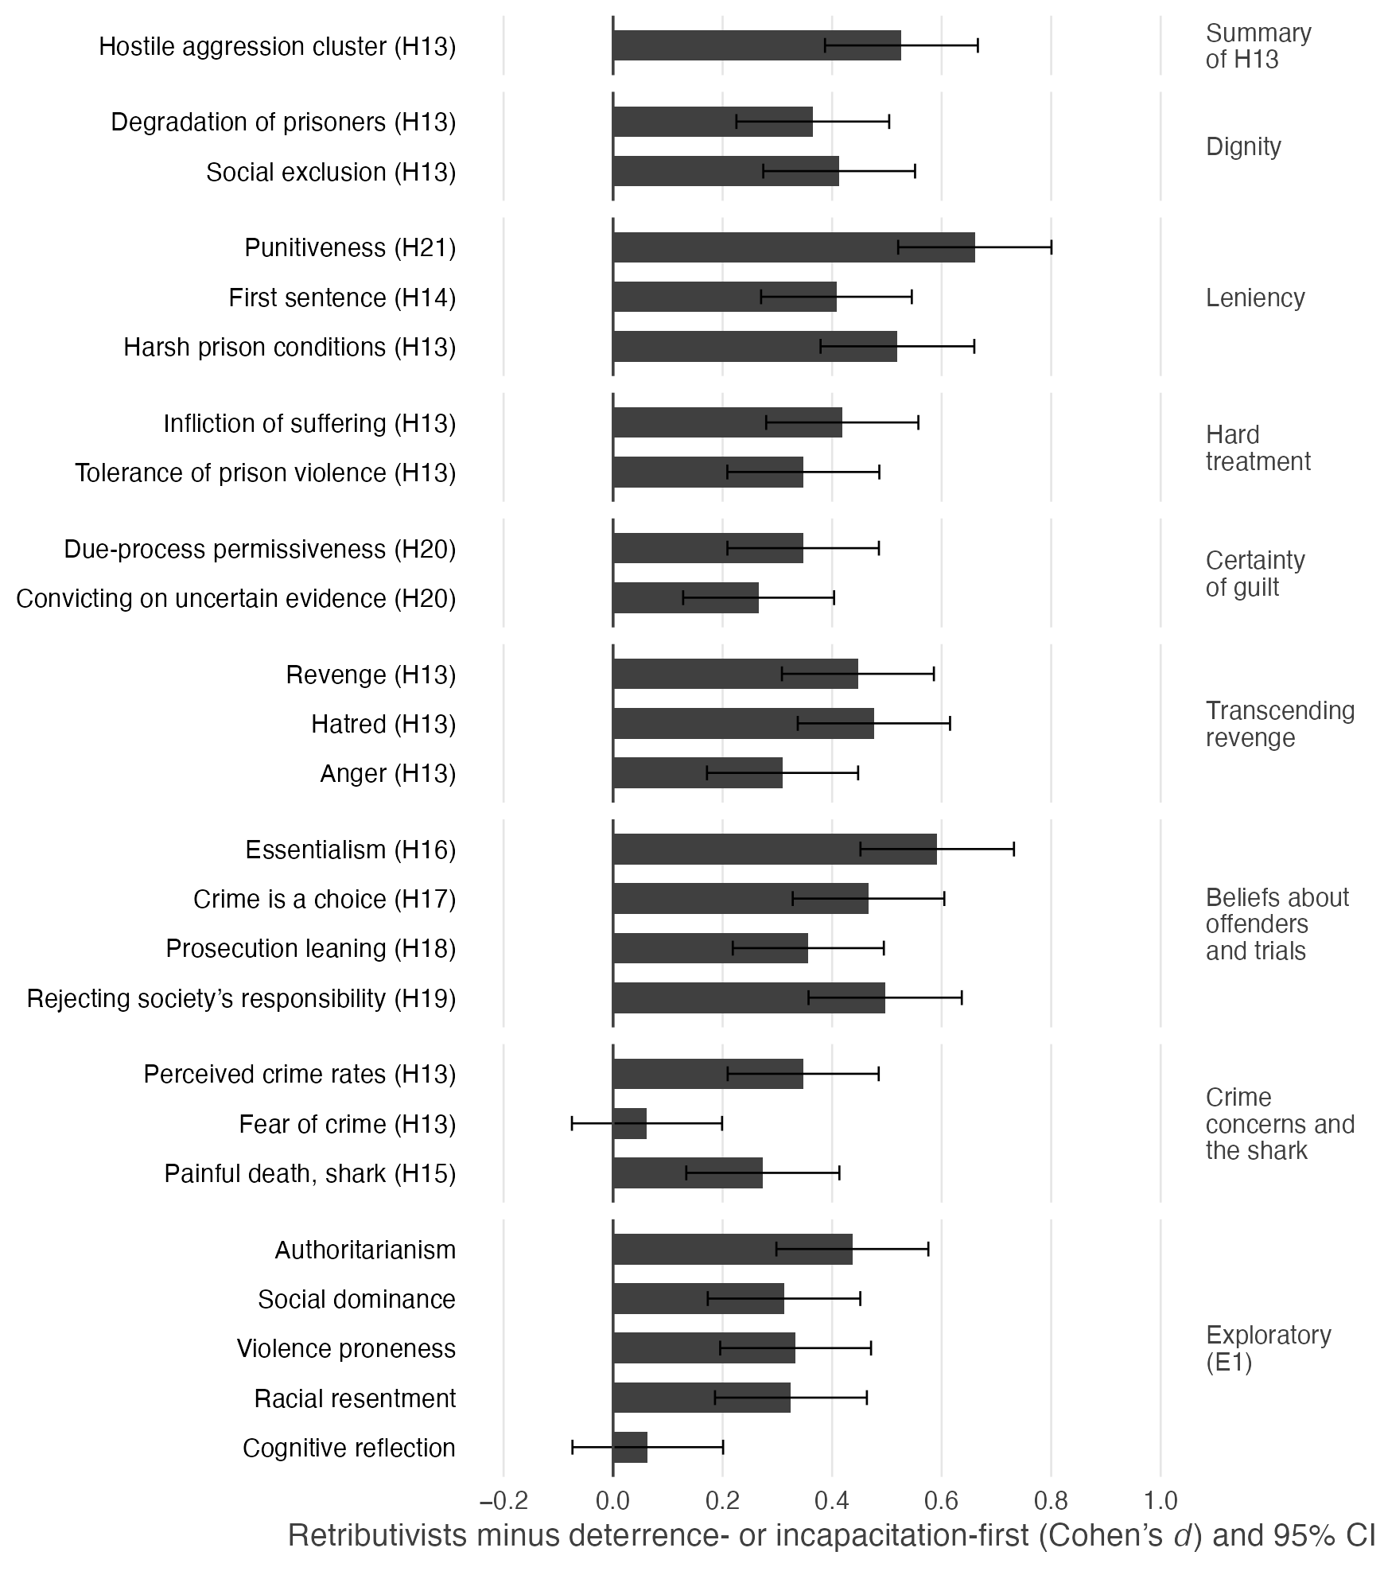
Note. Bars show Cohen’s d for the 371 participants who ranked retribution first minus the 453 who ranked deterrence or incapacitation first, with 95% confidence intervals; this comparison leaves out the 124 who ranked rehabilitation first and was not registered. Measures are grouped as in Table S19: the H13 summary first, then the features of retributive theory each measure bears on (our grouping, not registered), then the registered measures that bear on no feature and the exploratory E1 measures. Punitiveness is the mean of its six standardized components, one of which is the first sentence. E1 was registered as exploratory; for cognitive reflection the prediction was a lower score. Cognitive reflection is the two-item score (n = 369 and 452). Punitiveness without the sentence, the three-item cognitive reflection score, and the shark decision are not plotted; Table S19 gives them, every plotted value, and the registered comparison with all 577 other participants.
Under the other three registered groupings, the median d ranged from 0.20 to 0.40. Of the 19 contrasts that all four registered groupings could run, 15 reached one-sided p < .05 under all four, and most contrasts also held with retributivism entered continuously (Supplementary Materials, Section S5).

Between 11% and 56% of retributivists endorsed each hostile attitude (H12)
H12 predicted that a sizeable share of retributivists would endorse each of eight hostile attitudes and that each attitude would correlate with punitiveness among them. The share endorsing each ranged from 11.1% [8.0, 14.7] (a painful death for the shark) to 56.3% [51.1, 61.4] (hatred toward offenders; Table S22; Figure 11). Among the participants who ranked deterrence or incapacitation first, in a descriptive comparison that was not registered, the share ranged from 5.3% to 36.2%. The preregistration set no criterion for a sizeable share, so this half of H12 cannot be tested. Among retributivists, punitiveness correlated with seven of the eight attitudes, from r = .258 [.160, .351] to .578 [.506, .642], each two-sided p < .001, but not detectably with the shark’s pain, r = .052 [−.050, .153], p = .32.

Figure 11
Participants Endorsing Each Hostile Attitude in Study 2, Among Retributivists and Among Participants Who Ranked Deterrence or Incapacitation First (H12)
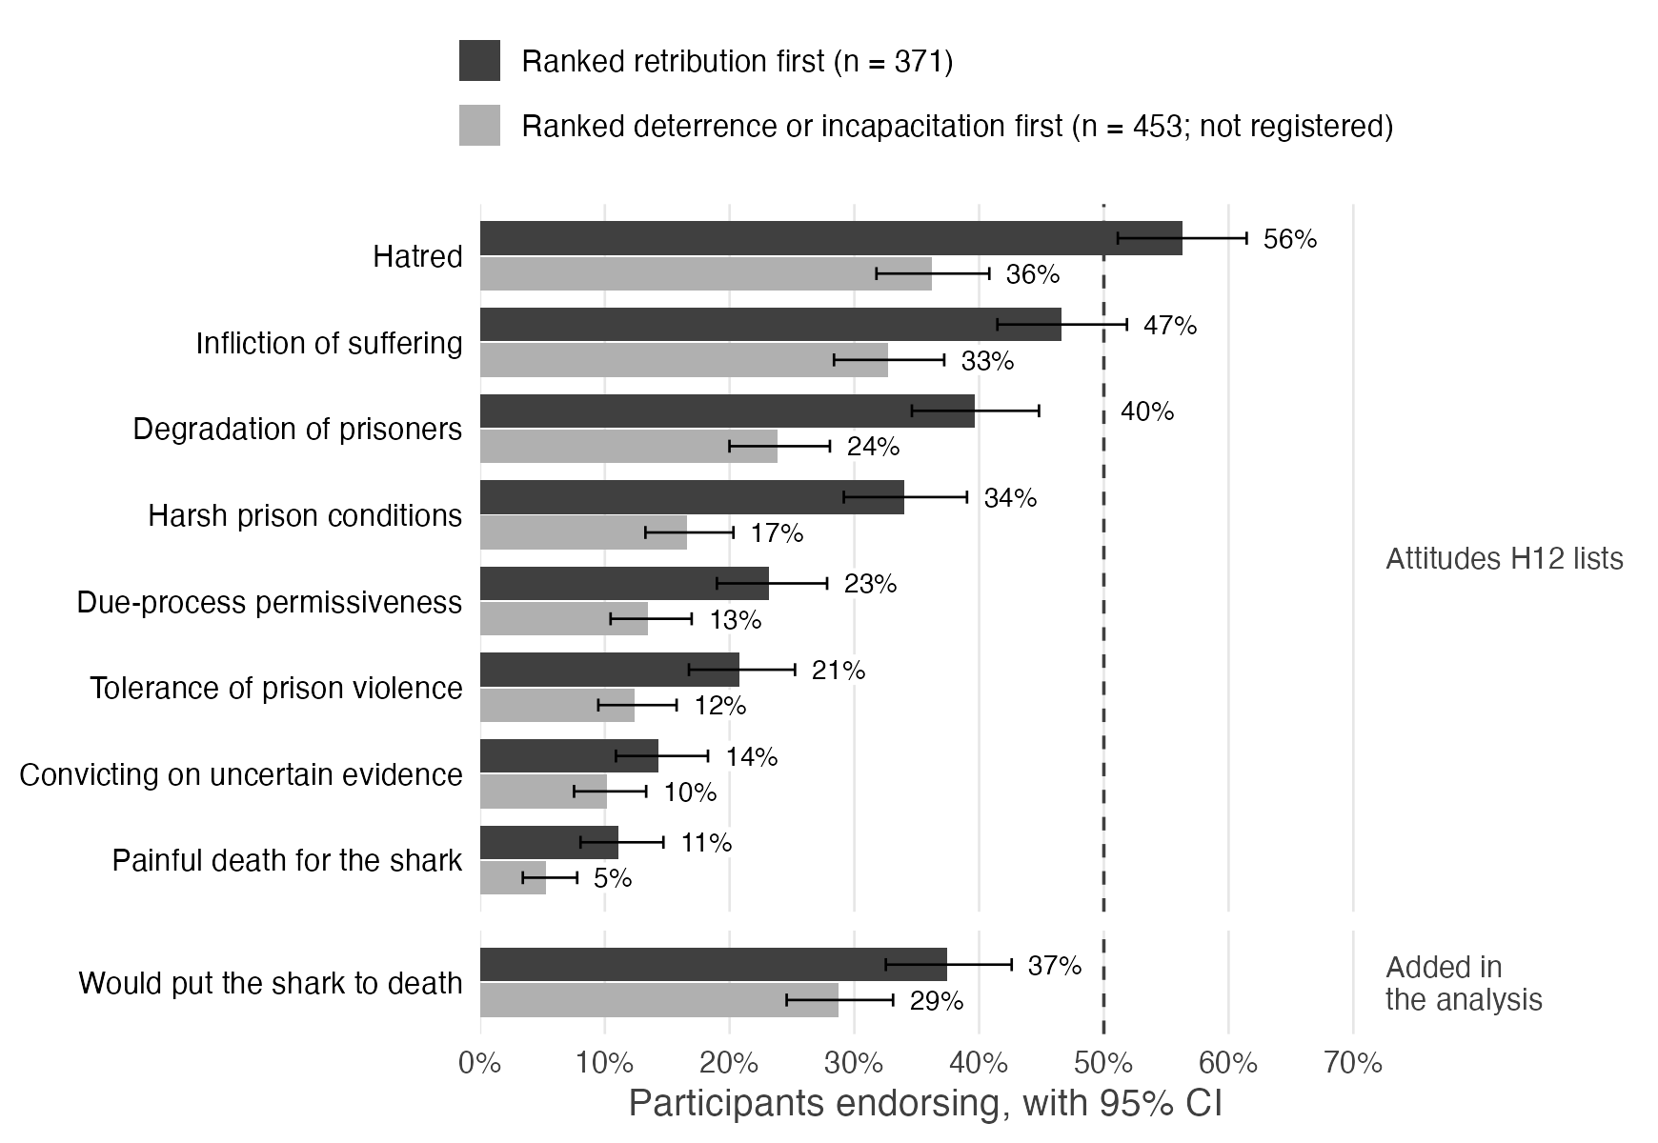
Note. Bars show the percentage of participants whose mean exceeded 4, the scale midpoint, with exact 95% confidence intervals; for the shark decision, the percentage answering yes. Dark bars are the 371 participants who ranked retribution first (H12); light bars are the 453 who ranked deterrence or incapacitation first, a comparison that was not registered and is descriptive. The dashed line marks 50%. The shark decision is not among the attitudes H12 lists; it was added in the analysis.

The whole-sample hypotheses among retributivists (H11)
The whole-sample results recurred among retributivists (Table S17). All twelve H1 correlations remained positive and significant after correction (r = .135 to .578), and 65 of the 66 intercorrelations among the correlates were positive (H3). H2 held, ∆r = .367 [.265, .471], as did H5, d = 0.64 [0.53, 0.75], and H9, against desert theory, d = 1.25 [1.12, 1.39], and against just deserts, d = 0.93 [0.80, 1.05]. All four limit measures correlated with punitiveness (H8), r = .258 to .532, and with revenge (H7), r = .287 to .503. H4 again failed in the direction opposite to the prediction, d = 1.31 [1.17, 1.45]. As in the whole sample, desert theory correlated more strongly with the severity index than with the proportionality principle (H6), r = .277 against .078, ∆r = .200 [.044, .352], two-sided p = .012. Punitiveness tracked revenge and desert theory about equally (H10), ∆r = .026 [−.060, .112], one-sided p = .28, but tracked revenge far more closely than just deserts, r = .570 against .157, ∆r = .414 [.295, .531], Z = 6.75, one-sided p < .001. H7’s second prediction, that the limits would be unrelated to just deserts, came out differently for the two scores. As in the whole sample, desert theory correlated positively with all four limit measures, r = .116 to .426, each two-sided p < .05, contrary to the prediction. Unlike in the whole sample, just deserts was not detectably related to any of them, r = −.075 to .090, two-sided p = .085 to .82, consistent with the prediction. On the registered just-deserts score, three of the four were not detectably related, and the fourth, convicting on uncertain evidence, correlated negatively, r = −.180 [−.277, −.079], two-sided p < .001, contrary to the prediction (Table S17).

Personality and cognitive reflection (E1)
E1, registered as exploratory and tested one-sided, predicted that retributivists would score higher on four personality measures and lower on cognitive reflection. Compared with the participants who ranked deterrence or incapacitation first, they scored higher on right-wing authoritarianism, violence proneness, racial resentment, and social dominance orientation, d = 0.31 [0.17, 0.45] to 0.44 [0.30, 0.58], each p < .001; contrary to E1, they did not score lower on cognitive reflection, d = 0.06 [−0.07, 0.20], one-sided p = .82 (Supplementary Materials, Section S5).
Our findings diverge somewhat from Carlsmith (2008) in this regard. Carlsmith found that when forced to choose their preferred justification, they split roughly equally between deterrence and retribution, whereas we found that retribution was picked twice as often (roughly 40% v 20%). JH: our methodology is probably more reliable. For one, Carlsmith presented participants with just those two justifications, whereas we presented the full choice set of four, which ended up diluting the support for deterrence more than retribution. Recall also that we sensitized our participants to the virtues of all four justifications by presenting them first with seventeen items that highlighted the reasons for preferring each of the justifications.
Agreement with the proportionality item is of questionable validity due to a desirability effect (no more, no less). The more valid measure is disproportionality.

General Discussion
These two studies carry sobering implications for the moral justifications of punishment and their avowed insulation from the psychology of the punisher. First, Study 1 and its replication in Study 2 revealed the strong presence of a dark side of punishment. Punitiveness was found to be closely tied to measures of hostile aggression toward convicted persons, including hatred, a willingness to degrade and inflict suffering, tolerance of physical and sexual assaults in prison, and support for revenge. Punitiveness was closely associated with the emotions of hatred and anger toward convicted persons. Punitiveness was also positively associated with measures of personality and ideology, including right-wing authoritarianism, racial resentment, and social dominance orientation. This suggests that public support for punishment is bound up with the anti-egalitarian sentiments embodied by social dominance orientation and racial resentment.” (see also Armour, 2020; Bobo & Johnson, 2004; Chiricos et al., 2004; Unnever & Cullen, 2010).
To provide a general sense of the strength of these psychological factors, we included a benchmark test in the form of two constructs whose association with punitiveness would be considered normatively appropriate: concern over crime rates and fear of being victimized. Together, these constructs formed the crime concerns cluster, which did indeed have a positive correlation with punitiveness (r = .360 in Study 1 and r = .427 in Study 2). This is as it should be: the more people are concerned about crime and the more they fear it, the more justifiable their support for punishment. But note that this correlation was the weakest of the four clusters, and considerably weaker than that of the hostile aggression cluster (r = .690 in Study 1 and r = .749 in Study 2; ∆r = .331 and .322, both p < .001). The most justifiable cluster of correlates is also the one least related to punitiveness.
“If punishment were explained entirely by the moral reasons the justifications give, hatred, revenge, degradation, and racial resentment should be unrelated to how much people want to punish. They are not, and they are more closely related to punitiveness than concern about crime is. Our data cannot show that these factors cause punitiveness, but they are hard to square with the view that punitiveness is independent of them. Darker psychological facets turn out to be intimately related to punitiveness, exhibiting considerably stronger correlations than factors such as crime concerns. The dark facets of the punisher’s psychology are a force to be reckoned with.
Study 2 set out to examine the possible role that psychology plays in the retributive justification of criminal punishment. As a preliminary question, we were interested to see whether “retribution as just deserts” is truly a robust concept. Our findings suggest that in lay judgment it is not. Across all participants, desert theory and the proportionality principle did not hang together as a coherent construct (r = .199). Troublingly, desert theory went much more strongly with the severity index, on which a high score means punishment at or above the gravity of the crime and never below it (r = .474).
We were particularly interested in whether people who subscribe to the retributivist framework do indeed heed the dictates of their creed. In this vein, we first retested the robustness of the just deserts construct among these participants alone. Again, the construct failed to hold together. Desert theory and the proportionality principle did not hang together (r = .078), and desert theory again went more strongly with the severity index (r = .277). We then compared how retributivist respondents differed from the other participants on their judgments, beliefs, emotions, and motivations toward punishment. We made this comparison in two ways: against all other participants, as preregistered, and, more strictly, against only those who ranked deterrence or incapacitation first. The two comparisons agree, and the effect sizes reported below come from the stricter one. Had the comparison revealed no substantial differences, that would have been a serious blow to retributivism given its avowed superiority over its rival justifications. In fact, the comparison is far more damning. We find that retributivists are more punitive and score higher on virtually every measure we compared: they recommend longer sentences, display heightened levels of hatred, revenge, and anger, and report stronger support for degrading prisoners, inflicting suffering, and subjecting them to harsher conditions. Retributivists are more inclined to circumvent defendants’ due process rights and more accepting of prison violence. Retributivists also seem to have different personality traits, scoring higher on right-wing authoritarianism, social dominance orientation, racial resentment, and violence proneness. They are also more likely to support killing a shark following a lethal shark attack (a scenario unrelated to crime) and were slightly more inclined to inflict suffering on it.
Consider these findings against the backdrop of the limitations on punishment that Kant imposed, and the five largely overlapping features that characterize contemporary retributive theory. Recall that most retribution theorists would agree that retributivism is a moral deontological theory that is grounded in respect for the dignity of the person being punished. Yet, in comparison to the other participants in our sample, retributivists were more hateful of convicted persons, and more supportive of degrading and inflicting suffering on them, and more supportive of harsh prison conditions. In addition to the apparent affront on prisoners’ human dignity, our findings reveal another facet of human agency, a conception that views human agency and the capacity to choose as a source of blame. Indeed, our retributivists respondents were considerably more likely to essentialize offenders as indelibly criminalistic (d = 0.59), to contribution of social factors to the criminal behavior (0.50) and they viewed crime as a personal choice (0.47). Retribution theorists insist that punishment is limited by the proportionality principle and, indeed, five in six retributivists agreed with it. But note that similar levels of agreement were reported also by the other participants. Keeping in mind that agreement with proportionality is the answer that self-presentation favors, so this item could hardly separate the groups. Note also that while a majority of all participants resisted the notion of punishing beyond the severity of the crime, retributivists were less disinclined to do so than the other participants. Retribution theorists claim that their framework supports more lenient punishment than the consequentialist frameworks, yet the retributivists in our sample were remarkably more punitive than other participants (d = 0.66). Our retributivists also recommended longer sentences, and were more likely to recommend putting a shark to death and least disinclined to inflict pain on it. The shark scenario removes desert altogether, since a shark is not a moral agent and thus cannot be deserving of punishment within a framework based on respect for human dignity. Yet retributivists were more willing to have it killed (37.5% against 28.7%), a difference that desert cannot explain but a retaliatory impulse can. Contrary to retribution theorists’ avowed fidelity to the certainty of guilt, our retributivists were less opposed to violating defendants’ due process rights and to accepting convictions based on shaky evidence. Retribution theorists also insist that punishment be exercised dispassionately, without anger or hatred. Yet, the retributivists in our sample reported feeling angrier at persons who commit crimes and more hateful of them. Perhaps the most notable finding concerns the insistence that retribution be devoid of a sense of revenge. It is striking to see that the retributivists in our sample endorsed revenge as a goal of punishment more strongly than the other participants did (d = 0.45). In sum, the retributivists in our sample were more likely to express hostile aggression and to hold a view of offenders as criminal to their core. Whether hostility drives the choice of retribution, or both flow from how offenders are seen, the data cannot say. The disconnect between how retribution theorists view their framework and how retributivists approach punishment could not be plainer. It is not hard to imagine that retributivist legal actors would be inclined to implement a particularly harsh punitive regime. Nor is it hard to imagine that the theory’s proclaimed benevolence could mask and legitimize the hostile motivations that fuel its practice.
One likely objection to this criticism is that it misses the mark in a profound way. The justifications of punishment are normative theories, whereas our findings are distinctly empirical. To beat a theory, the argument goes, one needs a countertheory, and empirics will not suffice. Philosophers of punishment could claim that their prescriptions for punishment are best viewed as ideal theories that merely propose normative frameworks and bear little responsibility for how those frameworks are put into practice by legal actors. In our view, as a matter of civic responsibility, the architects of our punitive regime should not be allowed to hide behind normative barriers to insulate themselves from the real-world effects of their work (Duff & Garland, 1994). Millions of Americans have been sent to prison based on theories that were conceived and crafted by moral philosophers for that very purpose. Those punishments were blessed by those philosophers and legitimized by the cumulative weight of their authority. Theories of punishment are not self-executing; they are designed to be put into practice by human beings. If it becomes apparent that legal actors are misapplying the normative frameworks, it is the role of the conscientious philosopher to call them out or right the ship. As a notable example, retributivism was dealt a major blow when the US Supreme Court virtually gutted the principle of proportionality as a restraint on excessive punishment (see, e.g., Harmelin v. Michigan, 501 U.S. 957, 1001, 1991). Yet, the theory of retribution has remained intact and, to the best of our knowledge, retribution scholars have stood by silently. James Whitman (2003) writes, “There is nothing about being ‘philosophers’ that licenses us to ignore [the legal system’s hostility to the principle of proportionality]. Quite the contrary: To the extent we claim to be seeking the correct moral stance, we have an obligation to take careful stock of the realities of the society in which we live” (p. 93).
Our findings might also have implications for retribution theory itself. What can be made of the fact that the retributivists in our sample revealed more hostile aggression and were more punitive than all other participants on every measure of punitiveness? What can be made of the fact that those participants departed further than other participants from nearly every core feature of the retribution framework that we measured. of the retribution framework? What can be made of the fact that our retributivists were more hateful, and vengeful? Might there be something fundamentally wrong with retribution theory? Is there a solution to the longstanding impasse between retributivism as just deserts and retributivism as revenge (Gerber & Jackson, 2013; Jacoby, 1983; Vidmar, 2000) or, in the words of Jeffrie Murphy (2012), the dialectic between the one view that stresses “moral desert…human dignity and responsibility” and the other “that tempts us to self-deceptive cruelty? (pp. 85-86). We propose that many of these questions fade away once we let go of the view that moral philosophy has a monopoly on explaining why we punish. Our data suggest that dark psychology seems to provide a better explanation than an edifice made only of dispassionate first-order moral principles.
Once again, a retributivist could invoke the conceptual mismatch between the normative nature of their theory and the empirical nature of our findings. Good theories can be abused by bad people or misapplied out of bad motives but, the argument goes, that does not refute the soundness of the theory. That is a tempting objection, but it seems to be defeated by the writings of retribution theorists themselves. From the very inception of the theory, retribution scholars have gone out of their way to distinguish the theory from any form of psychological impulse. Long before any psychological critique came into existence, Kant seemed to have been protesting too much by repudiating the role of passion in punishment. Recall that Kant deemed punishment an act of pure intellect, born of a categorical imperative that refrains from “repaying another’s enmity with hatred out of mere revenge” (Kant, 1797/1996, 460-61). As mentioned, the repudiation of a psychological impulse has been stated by countless retributivist scholars, including Herbert Morris (1968), Joel Feinberg (1988), and others. Recall that Robert Nozick (1981) insisted that retribution is not merely a “disguise for revenge” (p. 382), and George Fletcher (2000) warned us against identifying retributivism with vengeance or revenge “any more than love is to be identified with lust” (p. 417). Further evidence of engagement with psychology in retributive thinking comes from the personal evolution of Jeffrie Murphy. Reflecting on his earlier justifications of retributivism, Murphy (2007) explains: “If I had been a kinder person, a less angry person, a person of more generous spirit and greatness of soul, would robust retributivism have charmed me to the degree that it at one time did? I suspect not” (p. 18). It would be strange to allow retribution theorists to consistently deny that their framework may be driven by dark psychological matter but then, in the face of contrary evidence, flip the script on the grounds that such proof is immaterial to their normative theory.
These data could serve as an invitation to retribution theorists to peer into the tenets of their framework and probe what it is about their approach that attracts supporters who are so punitive, harsh, and hostile. One likely answer is that the beneficent facet of retribution exists entirely on the theory’s backstage, in the circles of retribution theorists, well out of sight of lay people. To lay retributivists, retribution is the theory that seems to need no explanation. Recall that our participants were asked to rank, from the best reason to the weakest, the four theories, three of which were described as serving a prosocial goal (e.g., “Punishment deters others from committing crimes”). In contrast, the retribution justification was simply labeled “Criminals deserve to be punished,” which could well have been understood as requiring no social benefit. In other words, for the most hostile of participants, retribution was the theory of choice because it needed no explanation or justification, and thus seemed to fit with their felt urge to punish.
This account is consistent with our findings from the personality trait measures. Recall that relative to all other participants, retributivists were found to score higher on right-wing authoritarianism, social dominance orientation, and racial resentment, and were also more prone to violence. These findings should come as no surprise given that these traits are known to be associated with punitiveness, harshness, and hostility toward convicted persons. Keep in mind that, by their nature, such measures tend to capture relatively deep and stable facets of personality. Our data cannot establish direction, but because these measures tap relatively stable dispositions, it seems more likely that retribution theory attracts people with these traits than that supporting retribution leads people to adopt them.
These studies are not intended to impugn or call into doubt the integrity of the theorists who stand for retribution. One can safely assume that they wholeheartedly embody the beneficent features by which the retributive community defines itself. Still, we face one nagging concern, which speaks to a fundamental piece of the theory that seems to have gone missing: we are told that punishment is justified by desert theory, but it is less than clear what justifies the underlying principle of desert.
Over the years, retribution scholars have come forward with a variety of rationales for their theory. The rationale for Kant’s deontological rule emanated from a construction by which inflicting an undeserved evil on another person is tantamount to inflicting that evil on oneself, the solution to which is jus talionis (an eye for an eye, a tooth for a tooth). Famously, Herbert Morris (1968) framed punishment in terms of fairness, as a means of repaying the debt for the unfair advantage gained by committing the crime. Michael Moore’s (1987) proposition that punishment is justified because and only because offenders deserve it has become the canonical expression of desert theory. Moore goes on to propose a rationale based on a hypothetical sense of guilt experienced by the wrongdoer. Moore explains that he would personally rather be punished than experience guilt and regret, and that denying a convicted offender a similar opportunity for penance would be “elitist and condescending” (1997, p. 148). Hegel (1821/1991) argued that punishment nullifies the crime. Both Hegel and Morris (1968) argued that punishment is a way of showing convicted persons the respect they are owed as free and responsible beings, such that a failure to punish wrongs them. Morris (1981) also advanced a paternalistic theory of retribution by which punishment is an educative act that conveys the wrongness of the offense, and Antony Duff’s (1999, 2001) censure-based version adds the goal of bringing offenders to recognize and repent for their wrong deeds. Arie Freiberg (2001) proposed a forfeiture approach, by which convicted offenders are deemed to have surrendered their civil rights and excluded themselves from the body politic. Jean Hampton (1991) proposed a victim affirmation theory by which punishment reaffirms the victim’s equal worth to overcome the wrongdoer’s affront toward her, Kaufman (2013) emphasizes the restoration of the victim’s honor, and the late Dan Markel (2011) pointed to punishment as a means of denying the offender’s act of superiority over fellow citizens. Markel also viewed punishment as an exercise of the state’s right to defend its own legitimate political authority. In all, John Cottingham (1979) has counted nine such rationales and John Mackie (1982) has identified seven.
This proliferation of rationales should give us pause. For one, the mere fact that retributivists cannot agree on a rationale should make one wonder whether any principle is capable of providing the elusive moral justification for the principle of desert. Indeed, some rationales have been criticized by fellow retributivists, as demonstrated by critiques of fair play theory (Morris, 1968; Murphy, 1973) offered by Duff (1986, 2001), von Hirsch (1985, 1992), and Matravers (2000). Keep in mind that we are talking here of first-order moral reasons that purport to be necessary and perhaps also sufficient conditions for the somber task of depriving people of their liberty.
Moreover, the rationales themselves come across as less than compelling. Both Cottingham (1979) and Mackie (1982) found some of the rationales to be utilitarian principles in disguise. Cottingham observed that most of the rationales boil down to some form of debt repayment, which he viewed not as a theory but as a thin metaphor that “cuts remarkably little ice as a justificatory device” (p. 245). Mackie found a number of the rationales to be circular and concluded that “all these attempts to make sense of the principle of positive retributivism, as an independent principle with immediate moral authority, have signally failed” (1982, p. 6; see also Kaufman, 2016).
These critics have a point. One cannot but wonder how punishment could be justified based on Kant’s notion of what you do to others you do to yourself. Could jus talionis possibly work in a civilized society? Do we really want to inflict horrible bodily harms on convicted persons? How could punishment be deemed a repayment, and how does society benefit from that? Given that crimes are events that occurred in the past, how could they possibly be annulled? Do all crimes confer advantages to those who commit them? Should we refrain from punishing those who gained no advantage from committing deplorable acts? Do we really believe we can justify punishment to avoid the specter of being elitist and condescending for denying convicted persons the opportunity for penance? Can we say that punishment reaffirms the victim’s equal worth? How can we say that refraining from punishing offenders violates their dignity and then lock them in cages for years on end? Can we justify the state’s use of punishment as self-defense even after the offender has been apprehended and no longer poses a danger? Above all, is it not circular to claim that punishment is justified merely because offenders deserve it?
These rationales ride on values and intuitions that most people find appealing: parity, reciprocity, restoration of justice, fairness, debt repayment, human dignity. This intuitive appeal is bound to make the entire endeavor appear more civilized, palatable, and consistent with moral reasoning. The seemingly facile manner in which these rationales are proposed and, for the most part, accepted by the community of retribution scholars may well feel enigmatic. One possible explanation lies in the paradox of retribution (Westermarck, 1932. See also Mackie, 1982; Kaufman, 2013). The paradox stems from the firmly held sense that the retributive principle of punishment cannot be dislodged from our moral thinking, even as the principle “cannot be explained or developed within a reasonable system of moral thought” (Mackie, 1982, p. 3). As Mackie proposes, the paradox ceases to be puzzling when, “like Westermarck, we make the Humean move of saying that moral distinctions are founded on sentiment, not on reason” (1982, pp. 7–8). Perhaps, after all, the question is not which account (the psychological or the deontological) better explains the retributive impulse. As Jonathan Haidt (2001) and Joshua Greene (2008) have suggested, at bottom, deontological principles could be nothing other than rationalizing outgrowths of emotional moral intuitions (see also Harman, 1977).

Methodological Limitations
These studies are not without methodological limitations. First, one could question the validity of our results because of the type of questioning we used. Lay attitudes toward crime and punishment are generally found to be malleable, or mushy (Cullen et al., 2000), so that responses might be overly sensitive to the questioning format. That is a valid concern that can, at best, be mitigated, but never completely solved. In that regard, we devoted multiple questions to most constructs, reverse-keyed some items, randomized questions within blocks, and deferred the sentencing decisions until near the end of the survey to prevent the crime vignette (a second-degree murder conviction) from influencing the other measures. For the same reason, in Study 2, the focal block that gauged support for the goals of punishment was placed before all other blocks. To afford participants the opportunity to reflect on the crucial prioritization of the goals, we presented that task only after they had rated 17 statements covering the entire range of goals. It is also true that lay attitudes toward crime, most notably perceptions of crime rates, are frequently inflated relative to actual levels and trends of crime (Pfaff, 2017; Pickett, 2019; Quillian & Pager, 2010). But note that our studies are not intended to gauge the actual facts about crime or even our respondents’ beliefs about them. Rather, we are mostly concerned with how psychological factors play out in the overall punitive mindset, which means that we look primarily at the relations among the different moving parts rather than at their absolute values.
As can be seen in the study’s supplemental materials, most of our questions asked participants to rate their agreement with short statements. This brevity, which was necessary to cover such a wide range of issues, can be said to hinder the validity of our findings. The critique speaks to the use of simple questions posed to people who, not having thought much about the issue, are asked to provide “top-of-the-head” reactions. This format, commonly used in opinion polls, has been found to yield more punitive responses than formats that give respondents more elaborate information about a case on which they are to make an informed decision (Doob & Roberts, 1984; de Keijser et al., 2007). This critique, while well established in the literature, does not seem squarely pertinent to our studies. Those findings were generated predominantly for the specific task of sentencing decisions made by the public (Roberts, 2011) and, as a matter of ecological validity, that task is very different from the one we are studying. We are interested not in the adjudicatory process, but in the ambient sense of punitiveness that affects public and political discourse on criminal punishment policy. In this discourse, statements are often flung around willy-nilly, in abstract and generalized terms, without any expectation of profound deliberation.
Finally, to explore the punitive mindset associated with retributivism, we first had to identify the participants who could be said to fall into that category. As discussed above, we used four different classification methods, which agreed with one another little more often than chance would (κ = .05 to .21). As stated in the preregistration, we relied mostly on the ranking task, which did in fact turn out to produce the differences that we expected, and larger ones than the alternative groupings did (median d = 0.51 in the comparison with all other participants; 0.20 to 0.40 under the other groupings). And as stated in results section, the prioritization task is subject to three methodological critiques. It is also worth remembering that no such measure can be precise, and many people may not fall perfectly and exclusively into a single category. Most retributivists will also believe to some extent in consequentialist goals, and vice versa. Thus, our classifications should not be viewed as rigid or perfectly accurate.

Conclusion
We propose three takeaways from this project. First, judging from the literature and discourse surrounding criminal punishment, one could reasonably infer that the entire endeavor can be explained through the prism of the dominant moral philosophical framework. Psychological factors, according to this view, play no role in explaining why we actually engage in the practice. This project sought to challenge this bifurcation by showing that the psychology of the punisher has a lot to say about why, how, and how much we feel the need to mete out criminal punishment. Second, the prevailing moral philosophical approaches tout their striving for lofty goals, such as restoring justice, reducing crime, addressing safety concerns, respecting the dignity of the punished, and rehabilitating offenders. In contrast, our studies reveal a cohesive mindset consisting of mostly dark emotions, motivations, and personality traits, most of which ought to be considered utterly inappropriate influences on this sensitive social practice. The dark side of punishment is a force that must be reckoned with. Ignoring or rejecting it would mean that we are bound to punish for reasons that are unknown to us and likely incompatible with our moral values. Third, retribution is depicted by its proponents as the justification that is most beneficent for the convicted person. We found that in situ, the reality is very different. Respondents who were classified as retributivists exhibited heightened levels of hostile aggression on virtually every measure.
The aim of this paper is not to condemn people for their punitiveness or hostile aggression toward offenders. We should of course strive toward a state of greater compassion and understanding of those who break our laws. But for all practical purposes, we have as yet little choice but to take those tendencies, however dark, as given. The retaliatory aggression that resides in us was shaped by evolution and modified by our enculturation, ideology, and life experiences. That is part of being human. The implications of these studies are directed instead at the discourse surrounding the justifications of punishment. This discourse can serve to sanitize the hostility that accompanies support for punishment, and is thus likely to have lent legitimacy to the regime of mass incarceration. A more honest discourse would promote a frank recognition that we punish in part to satisfy our own, often unsavory, psychic needs.

References
Aharoni, E., & Fridlund, A. J. (2012). Punishment without reason: Isolating retribution in lay punishment of criminal offenders. Psychology, Public Policy, and Law, 18(4), 599-625.
Allen, D. S. (1999). Democratic Dis-ease: Of Anger and the Troubling Nature of Punishment. In S. Bandes (Ed.), The passions of law (pp. 191-214). New York University Press.
Altemeyer, B. (1981). Right-wing authoritarianism. Winnipeg: University of Manitoba Press.
Armour, J. D. (2020). N*gga theory: Race, language, unequal justice, and the law. Cotsen Institute Press.
Barron, A. C., Berryessa, C. M., & de Vel-Palumbo, M. (2026). When we do not care about what happens to “criminals”: How character judgments influence indifference to incidental suffering in the criminal justice system. Law and Human Behavior, 50(5), 500–517.
Bates, D., Mächler, M., Bolker, B., & Walker, S. (2015). Fitting linear mixed-effects models using lme4. Journal of Statistical Software, 67(1), 1–48. https://doi.org/10.18637/jss.v067.i01
Batson, C. D., Kennedy, C. L., Nord, L.-A., Stocks, E. L., Fleming, D. A., Marzette, C. M., . . . Zerger, T. (2007). Anger at unfairness: Is it moral outrage? European Journal of Social Psychology, 37, 1272–1285. https://doi.org/10.1002/ejsp.434
Batson, C. D., Lishner, D. A., Cook, J., & Sawyer, S. (2005). Similarity and nurturance: Two possible sources of empathy for strangers. Basic and applied social psychology, 27(1), 15-25.
Baumeister, R. F. (1996). Evil: Inside human cruelty and violence. WH Freeman/Times Books/Henry Holt & Co.
Bentham, J. (1843/1962). Principles of penal law. In J. Bowring (Ed.), The works of Jeremy Bentham, ch. 6. Indianapolis: Liberty Fund.
Benjamini, Y., & Hochberg, Y. (1995). Controlling the false discovery rate: A practical and powerful approach to multiple testing. Journal of the Royal Statistical Society: Series B (Methodological), 57(1), 289–300. https://doi.org/10.1111/j.2517-6161.1995.tb02031.x
Ben-Shachar, M. S., Lüdecke, D., & Makowski, D. (2020). effectsize: Estimation of effect size indices and standardized parameters. Journal of Open Source Software, 5(56), Article 2815. https://doi.org/10.21105/joss.02815
Bizumic, B., & Duckitt, J. (2018). Investigating right wing authoritarianism with a very short authoritarianism scale. Journal of Social and Political Psychology, 6(1), 129–150. https://doi.org/10.5964/jspp.v6i1.835
Bobo, L. D., & Johnson, D. (2004). A taste for punishment: Black and white americans’ views on the death penalty and the war on drugs. Du Bois Review, 1(1), 151–181.
Buckholtz, J. W., Asplund, C. L., Dux, P. E., Zald, D. H., Gore, J. C., Jones, O. D., & Marois, R. (2008). The neural correlates of third-party punishment. Neuron, 60(5), 930-940.
Canty, A., & Ripley, B. (2025). boot: Bootstrap functions (R package version 1.3-32) [Computer software]. https://doi.org/10.32614/CRAN.package.boot
Carlsmith, K. M. (2008). On justifying punishment: The discrepancy between words and actions. Social Justice Research, 21(2), 119-137.
Carlsmith, K. M., & Darley, J. M. (2008). Psychological aspects of retributive justice. Advances in experimental social psychology, 40, 193-236.
Carlsmith, K. M., Darley, J. M., & Robinson, P. H. (2002). Why do we punish? Deterrence and just deserts as motives for punishment. Journal of personality and social psychology, 83(2), 284-299.
Carlsmith, K. M., & Sood, A. M. (2009). The fine line between interrogation and retribution. Journal of Experimental Social Psychology, 45(1), 191-196.
Chiricos, T., Welch, K., & Gertz, M. (2004). Racial typification of crime and support for punitive measures. Criminology, 42(2), 358–390.
Cottingham, J. (1979). Varieties of retribution. The Philosophical Quarterly, 29(116), 238–246. https://doi.org/10.2307/2218820.
Crockett, M. J., Özdemir, Y., & Fehr, E. (2014). The value of vengeance and the demand for deterrence. Journal of Experimental Psychology: General, 143(6), 2279-2286.
Cullen, F. T., Clark, G. A., Cullen, J. B., & Mathers, R. A. (1985). Attribution, salience, and attitudes toward criminal sanctioning. Criminal Justice and Behavior, 12(3), 305–331. https://doi.org/10.1177/0093854885012003003
Cullen, F. T., Fisher, B. S., & Applegate, B. K. (2000). Public opinion about punishment and corrections. Crime and justice, 27, 1-79.
Darley, J. M. (2009). Morality in the law: The psychological foundations of citizens’ desires to punish transgressions. Annual Review of Law and Social Science, 5(1), 1-23.
Darley, J. M. & Alter, A. L. (2013). Behavioural Issues of punishment, retribution, and deterrence. In E. Shafir (Ed.), The behavioural foundations of public policy, 173-205. Princeton NJ: Princeton University Press.
Davis, M.H. (1983). The effects of dispositional empathy on emotional reactions and helping: A multidimensional approach. Journal of Personality, 51, 167–184.
DeWall, C. N., Baumeister, R. F., Stillman, T. F., & Gailliot, M. T. (2007). Violence restrained: Effects of self-regulation and its depletion on aggression. Journal of Experimental Social Psychology, 43, 62–76.
de Keijser, J. W., Van Koppen, P. J., & Elffers, H. (2007). Bridging the gap between judges and the public? A multi-method study. Journal of Experimental Criminology, 3(2), 131-161.
de Quervain, D. J. F., Fischbacher, U., Treyer, V., Schellhammer, M., Schnyder, U., Buck, A., & Fehr, E. (2004). The neural basis of altruistic punishment. Science, 305(5688), 1254-1258.
Diedenhofen, B., & Musch, J. (2015). cocor: A comprehensive solution for the statistical comparison of correlations. PLOS ONE, 10(4), Article e0121945. https://doi.org/10.1371/journal.pone.0121945
Doob, A. N., & Roberts, J. V. (1984). Social psychology, social attitudes, and attitudes toward sentencing. Canadian Journal of Behavioural Science/Revue canadienne des sciences du comportement, 16(4), 269–280. https://doi.org/10.1037/h0080860
Duff, A. (1986). Trials and punishments. Cambridge University Press.
Duff, A. (1999). Punishment, communication, and community. Oxford: Hart.
Duff, A. (2001). Punishment, communication, and community. Oxford University Press.
Duff, R. Antony. (2011). Retrieving retributivism. In M. D. White (Ed.). Retributivism: Essays on theory and policy, 3-24. Oxford University Press.
Duff, R. A., & Garland, D. W. (1994). A reader on punishment. Introduction. Oxford University Press.
Enns, P. K. (2014). The public's increasing punitiveness and its influence on mass incarceration in the United States. American Journal of Political Science, 58(4), 857-872.
Fehr, E., & Fischbacher, U. (2004). Third-party punishment and social norms. Evolution and human behavior, 25(2), 63-87.
1988, Harmless Wrongdoing (The Moral Limits of the Criminal Law: Volume IV), New York: Oxford University Press.
Ferguson, T. J., & Rule, B. G. (1983). An attributional perspective on anger and aggression. In R. G. Geen & E. I. Donnerstein (Eds.), Aggression: Theoretical and empirical reviews (Vol. 1, pp. 41–74). Academic Press.
Fincher & Tetlock (2015), “Brutality under cover of ambiguity: Activating, perpetuating, and deactivating covert retributivism,” Personality and Social Psychology Bulletin, 41(5), 629–642.
Fileva, I., & Tresan, J. (2015). Will retributivism die and will neuroscience kill it?. Cognitive Systems Research, 34, 54-70.
Fletcher, G. P. (2000). Rethinking Criminal Law. New York: Oxford University Press.
Fox, J., & Weisberg, S. (2019). An R companion to applied regression (3rd ed.). SAGE Publications.
Frederick, S. (2005). Cognitive reflection and decision making. Journal of Economic Perspectives, 19(4), 25–42. https://doi.org/10.1257/089533005775196732
Freiberg, A. (2001). Three Strikes and You’re Out—It’s Not Cricket: Colonization and Resistance in Australian Sentencing. In M. Tonry and R. S. Frase (Eds.) Sentencing and sanctions in Western countries, 29-61. Oxford University Press.
Foucault, M. (1979). Part three: discipline. Discipline and punish: The birth of the prison. NY: Vintage Books.
Furman v. Georgia, 408 U.S. 238 (1972)
Gallup. (2025). Crime. https://news.gallup.com/poll/1603/crime.aspx
Garland, D. (2001). The culture of control: Crime and social order in contemporary society. University of Chicago Press.
Garland, D. (2025). Law and Order Leviathan: America’s Extraordinary Regime of Policing and Punishment. Princeton University Press.
Gault, B. A., & Sabini, J. (2000). The roles of empathy, anger, and gender in predicting attitudes toward punitive, reparative, and preventative public policies. Cognition and Emotion, 14(4), 495–520.
Gerber, M. M., & Jackson, J. (2013). Retribution as revenge and retribution as just deserts. Social justice research, 26(1), 61-80.
Gill, M. J., & Cerce, S. C. (2021). The blame intensity inventory: Assessing the propensity to blame harshly and its unique capacity to predict malicious satisfaction from offender victimization. Personality and Social Psychology Bulletin, 47(12), 1668–1685.
Green, D. A. (2012). Punitiveness and Political culture. Sociology Compass, 6(5), 365-375.
Greene, J. D. (2008). The secret joke of Kant’s soul. In W. Sinnott-Armstrong (Ed.), Moral psychology: Vol. 3. The neuroscience of morality: Emotion, brain disorders, and development (pp. 35–80). MIT Press.
Greene, J., & Cohen, J. (2004). For the law, neuroscience changes nothing and everything. Philosophical Transactions of the Royal Society B: Biological Sciences, 359(1451), 1775-1785.
Gross, H. (1979). A Theory of Criminal Justice. New York: Oxford University Press.
Haidt, J. (2001). The emotional dog and its rational tail: a social intuitionist approach to moral judgment. Psychological review, 108(4), 814–834. https://doi.org/10.1037/0033-295X.108.4.814.
Haidt, J. (2007) The new synthesis in moral psychology. Science, 316, 998–1002.
Hampton, J. (1991). Correcting Harms Versus Righting Wrongs: The Goal of Retribution, UCLA Law Review, 39, 1659-1702.
Harman, G. (1977). The Nature of Morality: An Introduction to Ethics. New York: Oxford University Press.
Harmelin v. Michigan, 501 U.S. 957 (1991).
Hegel, G. (1821/1991). Elements of the Philosophy of Right. A. W. Wood, Ed.; H. B. Nisbet, Trans., Cambridge University Press.
Ho, A. K., Sidanius, J., Kteily, N., Sheehy-Skeffington, J., Pratto, F., Henkel, K. E., Foels, R., & Stewart, A. L. (2015). The nature of social dominance orientation: Theorizing and measuring preferences for intergroup inequality using the new SDO₇ scale. Journal of Personality and Social Psychology, 109(6), 1003–1028. https://doi.org/10.1037/pspi0000033
Hobbes, T. (1651/1994). Leviathan, edited by Edwin Curley, Hackett Publishing.
Hogan, M. J., Chiricos, T., & Gertz, M. (2005). Economic insecurity, blame, and punitive attitudes. Justice Quarterly, 22(3), 392–412. https://doi.org/10.1080/07418820500219144
Jackson, J. C., Choi, V. K., & Gelfand, M. J. (2019). Revenge: A multilevel review and synthesis. Annual review of psychology, 70(1), 319-345.
Jacoby, S. (1983) Wild Justice: The Evolution of Revenge. New York: Harper & Row.
Kant, I. (1797/2017). The metaphysics of morals (M. J. Gregor, Ed.). Cambridge: Cambridge
Kaufman, W. R. (2013). Honor and revenge: a theory of punishment. Springer.
Kelly, E. I., Facquaert, E. F., Shaw, E., & Press, B. W. R. (2020). The retributive sentiments. The Routledge Handbook of the Philosophy and Science of Punishment, 101-110.
Kinder, D. R., & Sanders, L. M. (1996). Divided by color: Racial politics and democratic ideals. University of Chicago Press.
King, A., & Maruna, S. (2009). Is a conservative just a liberal who has been mugged? Exploring the origins of punitive views. Punishment & Society, 11(2), 147–169. https://doi.org/10.1177/1462474508101490
Krasnow, M. M., Delton, A. W., Cosmides, L., & Tooby, J. (2016). Looking under the hood of third-party punishment reveals design for personal benefit. Psychological science, 27(3), 405-418.
Lecci, L., & Myers, B. (2008). Individual differences in attitudes relevant to juror decision making: Development and validation of the Pretrial Juror Attitude Questionnaire (PJAQ). Journal of Applied Social Psychology, 38(8), 2010–2038. https://doi.org/10.1111/j.1559-1816.2008.00378.x
Mackie, J. L. (1982). Morality and the retributive emotions. Criminal Justice Ethics, 1(1), 3–10. https://doi.org/10.1080/0731129X.1982.9991689.
Markel, D. (2011). What might retributive justice be?. Retributivism: Essays on theory and policy, Mark D. White, ed, 49-72.
Marshall, J., Yudkin, D. A., & Crockett, M. J. (2021). Children punish third parties to satisfy both consequentialist and retributive motives. Nature Human Behaviour, 5(3), 361-368.
Matravers, M. (2000). Justice and punishment: The rationale of coercion. Oxford University Press.
McKee, I. R., & Feather, N. T. (2008). Revenge, retribution, and values: Social attitudes and punitive sentencing. Social Justice Research, 21(2), 138-163.
Mill, J. S. (1861/1977). Considerations on Representative Government. In Collected Works of John Stuart Mill. Vol. XIX. Toronto: University of Toronto Press.
Mischkowski, D., Glöckner, A., & Lewisch, P. (2018). From spontaneous cooperation to spontaneous punishment. Organizational Behavior and Human Decision Processes, 149, 59–72.
Moore, M. S. (1987). The moral worth of retribution. In F. Schoeman (Ed.), Responsibility, character, and the emotions, 179-219. New York: Cambridge.
Moore, M. S. (1997). Placing Blame: A Theory of Criminal Law. Oxford: Oxford University Press.
Morris, H. (1968). Persons and punishment. The monist, 52(4), 475-501.
Morris, H. (1981). A paternalistic theory of punishment. American Philosophical Quarterly, 18(4), 263–271 (1981).
Murphy, J. G. (1973). Marxism and retribution. Philosophy & Public Affairs, 2(3), 217–243
Murphy, J. G. (2007). Legal Moralism and Retribution Revisited. Criminal Law and Philosophy, 1(1), 5–20. doi:10.1007/s11572-006-9000-3.
Murphy, J. G. (2012). Punishment and the Moral Emotions: Essays in Law, Morality, and Religion. New York: Oxford University Press. https://doi.org/10.1093/acprof:osobl/9780199764396.001.0001.
Murphy, J. G. & Hampton, J. (1988). Forgiveness and mercy. Cambridge University Press.
National Research Council. (2014). The Growth of Incarceration in the United States: Exploring Causes and Consequences. Washington, DC: The National Academies Press.
Nikiforakis, N., & Mitchell, H. (2014). Mixing the carrots with the sticks: Third party punishment and reward. Experimental Economics, 17(1), 1-23.
Norrie, A. (2014). Crime, reason and history: A critical introduction to criminal law. Cambridge University Press, p. 345.
Nozick, R. (1981). Philosophical explanations. Harvard University Press.
Okimoto, T. G., Wenzel, M., & Feather, N. T. (2012). Retribution and restoration as general orientations towards justice. European journal of personality, 26(3), 255-275.
Pfaff, J. (2017). Locked in: The true causes of mass incarceration—and how to achieve real reform. Basic Books.
Pickett, J. T. (2019). Public opinion and criminal justice policy: Theory and research. Annual Review of Criminology, 2(1), 405-428.
Pratto, F., Sidanius, J., Stallworth, L. M., & Malle, B. F. (1994). Social dominance orientation: A personality variable predicting social and political attitudes. Journal of Personality and Social Psychology, 67(4), 741–763.
Primoratz, I. (1989). Punishment as language. Philosophy, 64(248), 187-205.
Quillian, L., & Pager, D. (2010). Estimating risk: Stereotype amplification and the perceived risk of criminal victimization. Social Psychology Quarterly, 73(1), 79–104.
R Core Team. (2025). R: A language and environment for statistical computing (Version 4.5.2) [Computer software]. R Foundation for Statistical Computing. https://www.R-project.org/
Rawls, J. (1955). Two concepts of rules. The Philosophical Review, 64(1), 3–32. https://doi.org/10.2307/2182230.
Revelle, W. (2026). psych: Procedures for psychological, psychometric, and personality research (R package version 2.6.5) [Computer software]. Northwestern University. https://doi.org/10.32614/CRAN.package.psych
Ristroph, A. (2006). Desert, Democracy, and Sentencing Reform, J. Crim. L. & Criminology, 96, 1293–1352.
Roberts, J. V. (2011). The future of state punishment: The role of public opinion in sentencing. In M. Tonry (Ed.), Retributivism has a past: Has it a future, 101-129. New York: Oxford University Press.
Rosseel, Y. (2012). lavaan: An R package for structural equation modeling. Journal of Statistical Software, 48(2), 1–36. https://doi.org/10.18637/jss.v048.i02
Sidanius, J., & Pratto, F. (2001). Social dominance: An intergroup theory of social hierarchy and oppression. Cambridge University Press.
Simmons, J. P., Nelson, L. D., & Simonsohn, U. (2012). A 21 word solution. Dialogue: The Official Newsletter of the Society for Personality and Social Psychology, 26(2), 4–7. https://doi.org/10.2139/ssrn.2160588
Steiger, J. H. (1980). Tests for comparing elements of a correlation matrix. Psychological Bulletin, 87(2), 245–251. https://doi.org/10.1037/0033-2909.87.2.245
Stephen, J. F. (1883). A History of the Criminal Law of England, vol. 2.
Tetlock, P. E., Visser, P. S., Singh, R., Polifroni, M., Scott, A., Elson, S. B., ... & Rescober, P. (2007). People as intuitive prosecutors: The impact of social-control goals on attributions of responsibility. Journal of experimental social psychology, 43(2), 195-209.
Tonry, M. (2007). Determinants of penal policies. Crime and Justice, 36(1), 1-48.
Tonry, M. (2011). Retributivism has a past: has it a future?. New York: Oxford University Press.
Twardawski, M., Gollwitzer, M., Pohl, S., & Bošnjak, M. (2022). What drives second- and third-party punishment? Conceptual replications of the “intuitive retributivism” hypothesis. Zeitschrift für Psychologie, 230(2), 77–83. https://doi.org/10.1027/2151-2604/a000454
Tyler, T. R., & Boeckmann, R. J. (1997). Three strikes and you are out, but why? The psychology of public support for punishing rule breakers. Law & Society Review, 31(2), 237–265. https://doi.org/10.2307/3053926
Unnever, J., & Cullen, F. (2010). Racial-ethnic intolerance and support for capital punishment. Criminology, 48(3), 831–864.
Vidmar, N. (2000). Retribution and revenge. In J. Sanders & V. L. Hamilton (Eds.), Handbook of Justice Research in Law (pp. 31–63), Kluwer.
von Hirsch, A. (1985). Past or future crimes: Deservedness and dangerousness in the sentencing of criminals. Rutgers University Press.
von Hirsch, A. (1992). Proportionality in the Philosophy of Punishment. Crime and Justice, 16, 55-98.
von Hirsch, A. (2009). Proportionate sentences: A desert perspective. In A. von Hirsch, A. Ashworth, & J. Roberts, eds., Principled Sentencing: Readings on Theory and Policy, 115-125. Portland, OR: Hart Publishing.
von Hirsch, A. (2017). Deserved criminal sentences. Oxford: Hart Publishing.
von Hirsch, A., & Ashworth, A. (2005). Proportionate sentencing: Exploring the principles. Oxford University Press.
Westermarck, E. (1932). Ethical Relativity. London: Kegan Paul, Trench, Trubner & Co.
Whitman, J. Q. (2003). A plea against retributivism. Buffalo Criminal Law Review, 7(1), 85-107.
Wozniak, K. H. (2016). Perceptions of prison and punitive attitudes: A test of the penal escalation hypothesis. Criminal Justice Review, 41(3), 352-371.
Yudkin, D. A., Bavel, J. V., & Rhodes, M. (2020). Young children police group members at personal cost. Journal of Experimental Psychology General, 149(1), 182–191. https://doi.org/10.1037/xge0000613.
Zou, G. Y. (2007). Toward using confidence intervals to compare correlations. Psychological Methods, 12(4), 399–413. https://doi.org/10.1037/1082-989X.12.4.399

